Project Edulead

**USER MANUAL**

**Student Lifecycle Management System**

**Module-Admission**

**February 2021, Version 1.0**

**Sustainable Outreach and Universal Leadership Limited**

**Sign off Date Signature Client Signature Consulting**

Table of Contents

About this Manual 3

Education Settings 4

Education Configuration 5

Module 1: Admission 7

1. Masters………………………………………………………………………………………………………..7

1.1 Department 7

1.2 Program Grade 8

1.3 Program 9

1.4 Semesters 11

1.5 Courses 12

1.6 Classroom 13

1.7 Academic Year 15

1.8 Academic Term 16

2. Student & Instructor………………………………………………………………………………..17

3. Admission Masters…………………………………………………………………………………….30

4. Counselling………………………………………………………………………………………………..35

5. Application & Enrolment………………………………………………………………………….36

6. Branch Change & Exchange Application…………………………………………………42

7. Fees……………………………………………………………………………………………………… …..47

8. Tools ………………………………………………………………………………………………………….51

9. Reports……………………………………………………………………………………………………..52

# About this Manual

This User Manual acts as a reference for ERP- EduLead by describing its various concepts and abilities, and by leading the user through the basics of EduLead software. It also provides a detailed reference for all of the EduLead SLCM (Student Lifecycle Management) functionalities.

The User Manual describes all the processes and functionalities regarding various modules and its abilities to conduct the smooth transactions and integrations within the modules.

The software EduLead is an open-source, easy to use and customize, actively maintained, economical and well supported.

Throughout this manual it is assumed that the reader has a working knowledge of about Student Lifecycle Management and basic computer skills and knows how to:

* Use keyboard and mouse
* Use web browsers to access the EduLead website
* Locate, open and save data files.
* Edit, cut, paste and text.

The SLCM consists of 3 Modules mainly:

1. Admission
2. Academics
3. Examination

This User Manual consists of the **Admission Module** for End User reference and guidance. The manual describes how to use the Standard interface. As mentioned, it contains instructions that the users must follow during the operation and servicing of **EduLead**. Diverting from the workflow as mentioned in the user manual may result in errors and non-functioning of the software EduLead. It is advisable that the end users must abide by the instructions as mentioned in the user manual.

# Education Settings

The Education Settings will allow you to do a basic setup for your Institute wherein you can define the Academic Year, Academic Term, and other defaults for your EduLead account.

These configuration settings will have an impact throughout the module.

To access Academic term, go to:

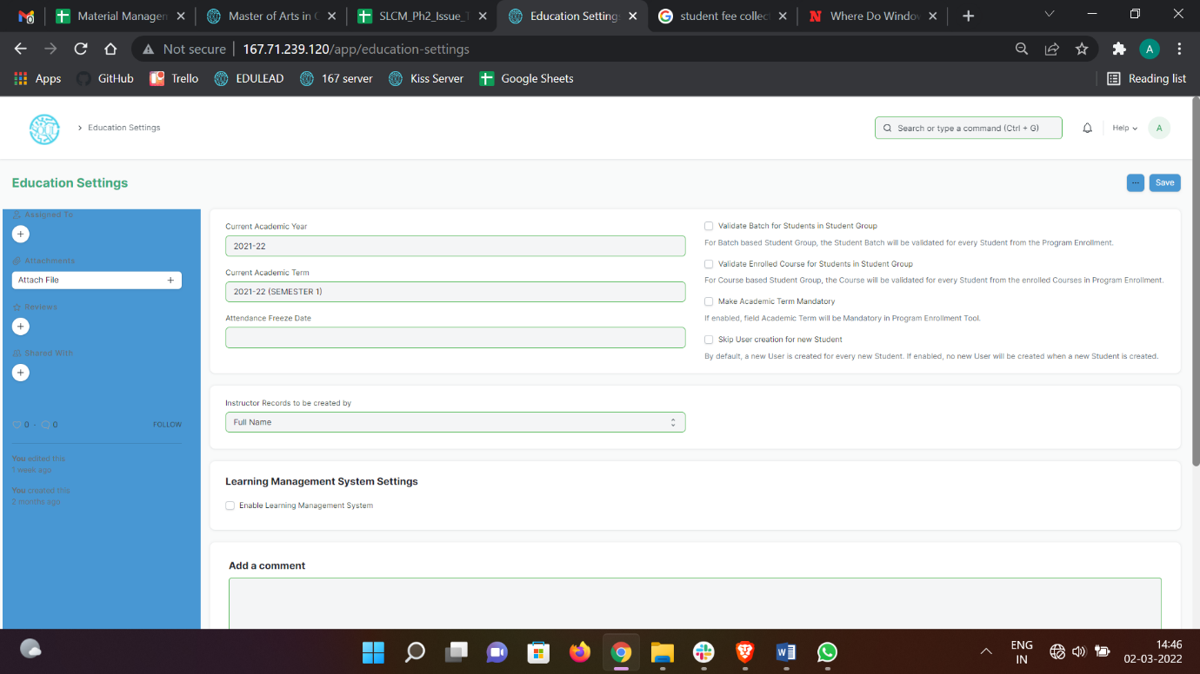Home > Admission > Settings > Education Settings

#### Steps to configure Education Settings

1. Select the current Academic Year. This will become the default Academic Year throughout your account.
2. Select the current Academic Term. This will become the default Academic Term throughout your account.
3. Select the Attendance Freeze date. Any attendance captured after the Attendance Freeze Date would not be valid.
4. Select how you want the Instructor Records to be created, using Full Name, using Naming series or using Employee Number.
5. Instructor Record to be created by: You can select how you want the Instructor Records to be created in your EduLead system, whether it should be by Full Name, by Naming series, or by Employee Code.

#### Configuring Properties

1. **Validate Batch for Students in Student Group:** When adding students to a student group via Batch, the system will verify whether the student belongs to that batch or no, and if the same has not happened, an error will be shown while saving the Student Group.
2. **Validate Batch for Students in Student Group:** When adding students to a student group via Course, the system will verify whether the student is enrolled to that course or no, and if the same has not happened, an error will be shown while saving the Student Group.
3. **Make Academic Term Mandatory:** When enabled, this option will ensure that while creating a Program Enrollment via the Program Enrollment Tool, the user has to enter the Academic Term.
4. **Skip User Creation for New Student:** Whenever a new student is created, by default a User is created against it. If this option is enabled, no new User will be created when a new Student is created.

# Education Configuration

The Education Configuration will allow you to do a basic setup for your Institute wherein you can define the Student Registration Naming for Admission process, Seat Reservation based on Category, Exam Fees and other defaults for your EduLead account.

These configuration settings will have an impact throughout the module.

To access Academic term, go to:

Home > Admission > Settings > Education Configuration

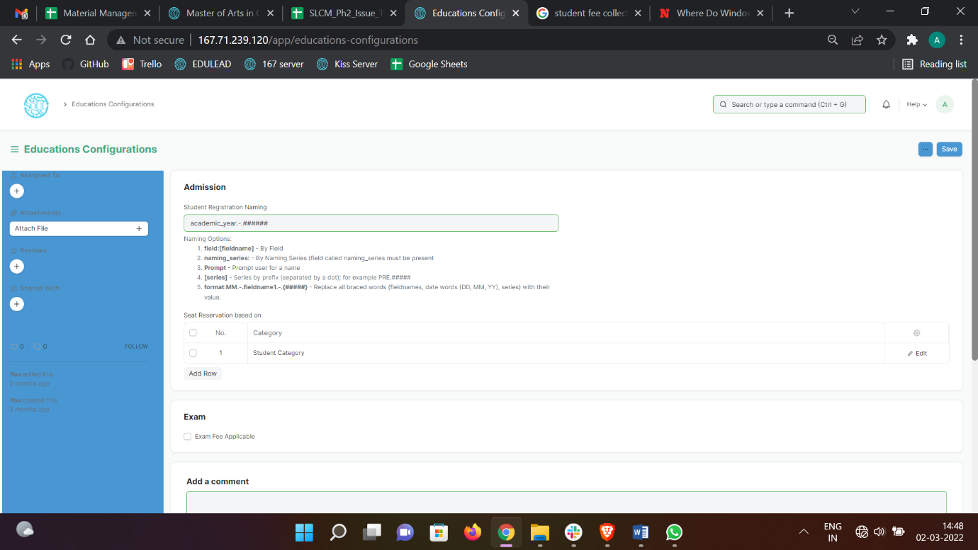

#### Steps to configure Education Settings

* + - 1. Select the current Academic Year format such as academic year.-.#####. This will become the default Naming Options for Student Registration Naming.

Naming Options can be defined in various ways such as:

* **field: [fieldname]** - By Field
* **naming_series:** - By Naming Series (field called naming_series must be present
* **Prompt** - Prompt user for a name
* **[series]** - Series by prefix (separated by a dot); for example, PRE.#####
* **format: MM.-.fieldname1.-.{#####}** - Replace all braced words (fieldnames, date words (DD, MM, YY), series) with their value.

1. Select the Seat Reservation based on Category. This will become the various categories based on which Admission shall be conducted.
2. The Categories that can be implemented are:

* Student Category
* Gender
* Physically Disabled

1. Select if Exam Fees applicable or not

# Module 1: Admission

## Masters

### Department

**A Department is a specialized functional area or a division within an organization.**

You can configure the Departments in your organization, set Leave Block List, and also Leave and Expense Approvers for the same.

To access Department, go to:

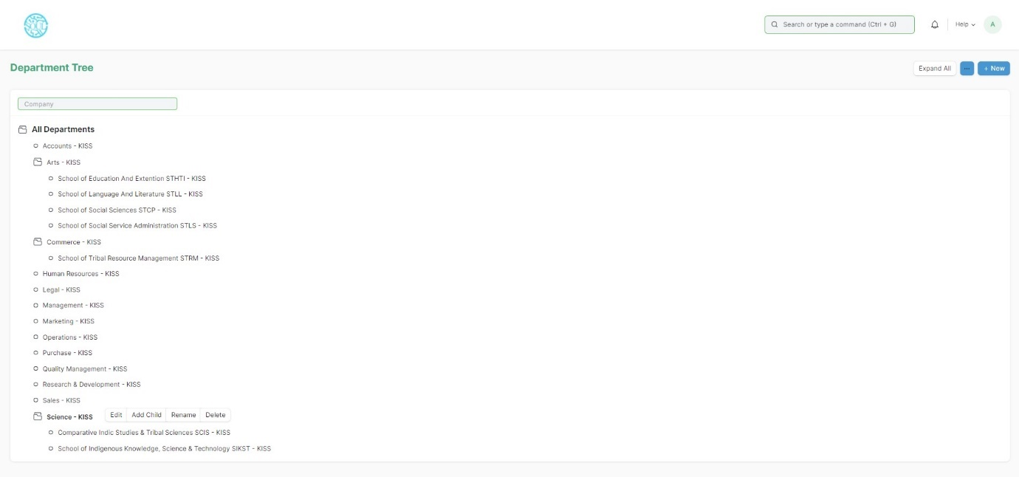Home > Admission > Masters > Department

Department is a tree-structured master, which means you can create parent departments and sub-departments as shown below:

#### Prerequisites

Before creating a Department, it is advisable you create the following documents:

* Company
* Leave Block List

#### How to create a Department?

1. Go to the Department list, click on New.
2. Enter Department name.
3. Select Company name.
4. Select “Is Group” and “Is Stream” if there are any child department under the parent department.
5. Select Leave Block List (optional) applicable for this department.
6. Save.

### Program Grade

A Program Grade is a specialized functional area or a division within the Department.

You can add Program Grade, modify and Programs can be linked to it.

To access Program Grade, go to:

Home > Admission > Masters > Program Grade

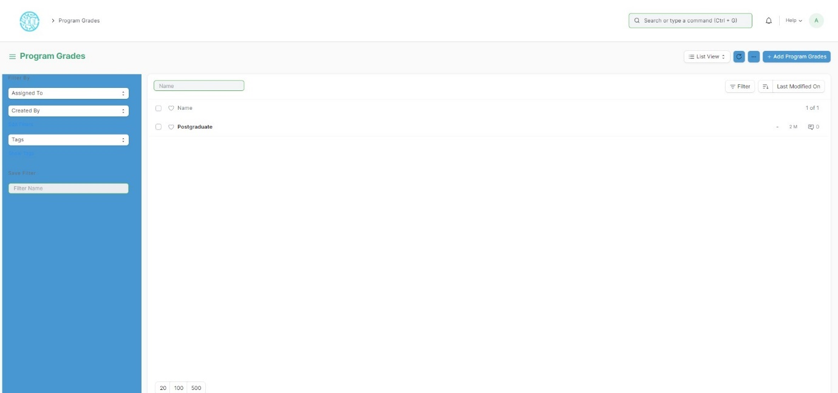

#### How to create a Program Grade?

1. Go to Program Grade list, click on Add Program Grade.
2. Enter Program Grade Name
3. Save.

The following are the various forms where Program Grade is a relevant field:

* 1. Student Admission
  2. Student Applicant
  3. Programs
  4. Student Reregistration Tool
  5. Counselling Structure
  6. Program Enrollment

### Program

A Program will have an educational curriculum defined by your institute to streamline the learning process and goals in each subject or course.

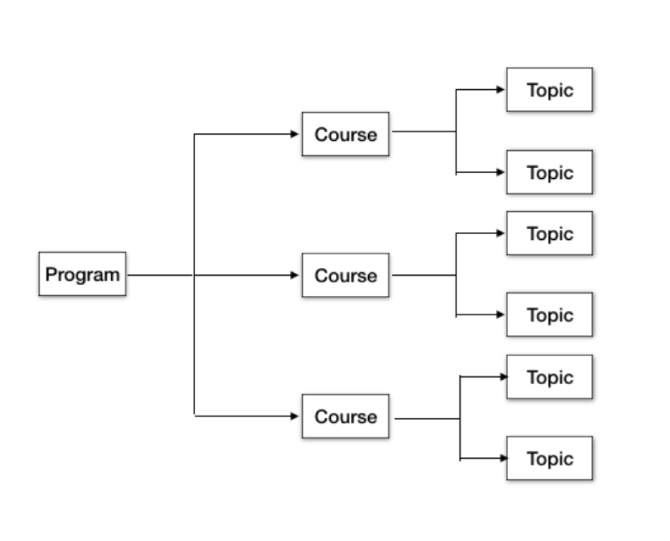For example, Economics Major would be a Program taught at an institution that will have various courses within.

To access the Program list, go to:

Home > Admission > Masters > Program

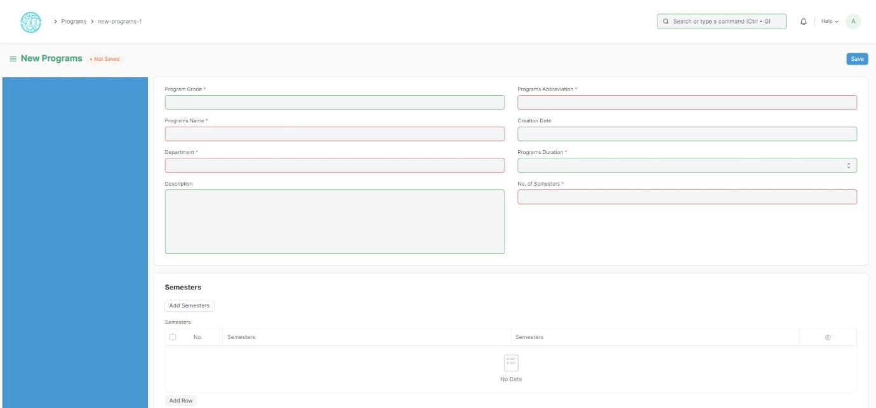

#### Prerequisites

To create a New Program, it is advised to create the following first:

1. Department
2. Course

#### How to create a new Program?

1. Go to the Program list and click on New.
2. Enter the Program Name and the Program Abbreviation.
3. Select the Department for the Program.
4. Select and add the courses within the Program.
5. Save.

*Description: Add the description of the Program which you want to be visible on the portal*.

### Semesters

A semester is individual part of a program. A semester system divides the academic year into different sessions which have various course enrollments enlisted in them.

For example, a program in Computer Science in B. Tech can consists of 4 semesters.

To go to Semesters, go to:

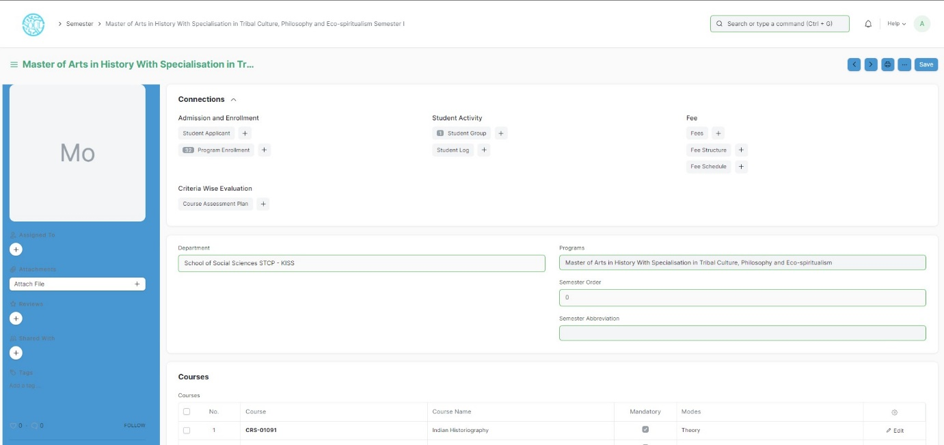Home > Admission > Masters > Semesters

#### Prerequisites

To create a New Semester, it is advised to create the following first:

* + - 1. Program

#### How to create a new Semester?

1. Method 1:
   1. Upon saving the Program we can add Semesters in the Semesters table and save the Program.
   2. The semesters get automatically saved and linked with the respective programs.
2. Method 2:
   1. Go to the Semester list and click on add Semester.
   2. Select and enter the Semester Name.
   3. Select and enter Program.
   4. Select and enter the Semester Abbreviation.
   5. Select and add courses if required.
   6. Save.

### Courses

A course can be considered as a subject or a part of an educational program which is to be taught for a term.

For example, if for a particular term, Economics Major is a program taught in the institute, then Mathematical Methods for Economics would be a Course covered under the program.

A course will have a set of topics that are to be covered under its scope.

To access the course list, go to:

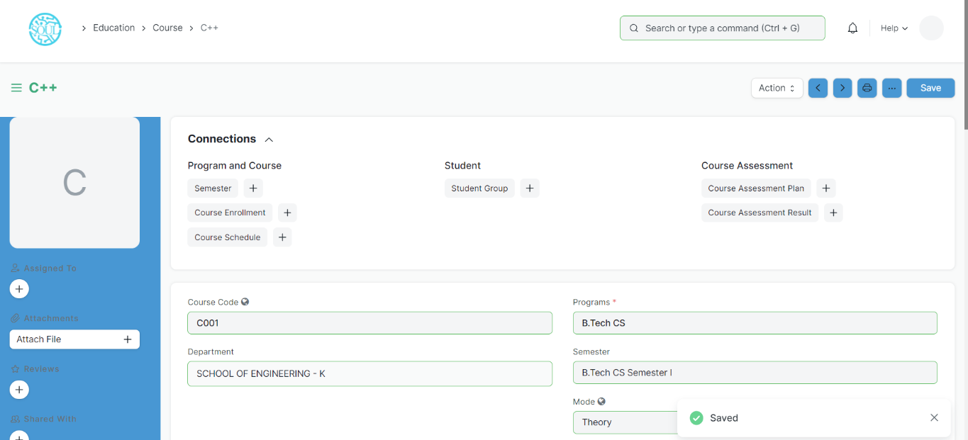Home > Admission > Masters > Course

#### Prerequisites

Before creating a course, it is advised to create:

1. Department
2. Topics

#### How to create a course?

1. Go to Course List and click on New.
2. Enter the Course Name.
3. Select the Department under which this course is being made.
4. Add the Topics. You can also create the topics from here itself.
5. Add the Description for the course.
6. Save.

#### Course Evaluation

For every new Course a User can have an Evaluation setting where in they can define the criteria based on which the students will be assessed for the course.

1. Default Grading Scale: A default Grading Scale can be set up for the course, wherein you can define what would be the achievement level of the student based on the scores they earn for a course.
2. Assessment Criteria: You can define the Criteria-wise Evaluation for this course wherein based on the different parameters of assessment, the student's understanding of the subject would be assessed.

#### More Actions

Once the course has been created, the following documents can be created from the course, which will later be linked to the course.

* 1. Program
  2. Student Group
  3. Course Schedule
  4. Evaluation Plan

### Classroom

Classroom refers to a tutoring space which can be set as the venue for courses or examinations.

Examples of a room are Examination Halls, Classrooms, or Labs. The Room will have details like Room number and Room Capacity.

To access Room, go to:

Home > Admission > Masters > Classroom

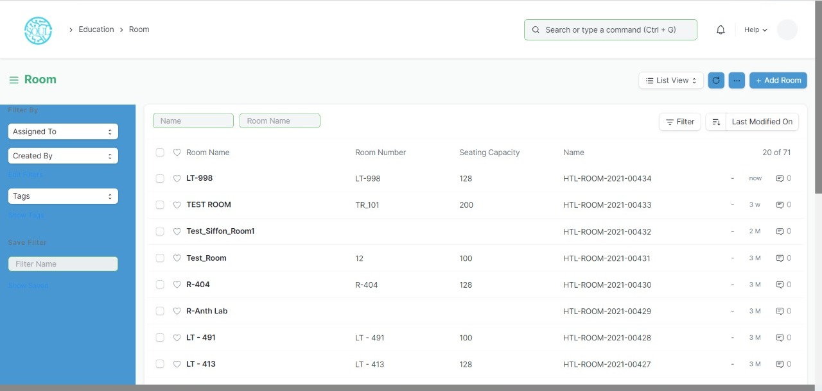

#### How to create a Room?

1. Go to the Room list and click on New.
2. Add the name of the room.
3. Add the Room Number for the selected room.
4. 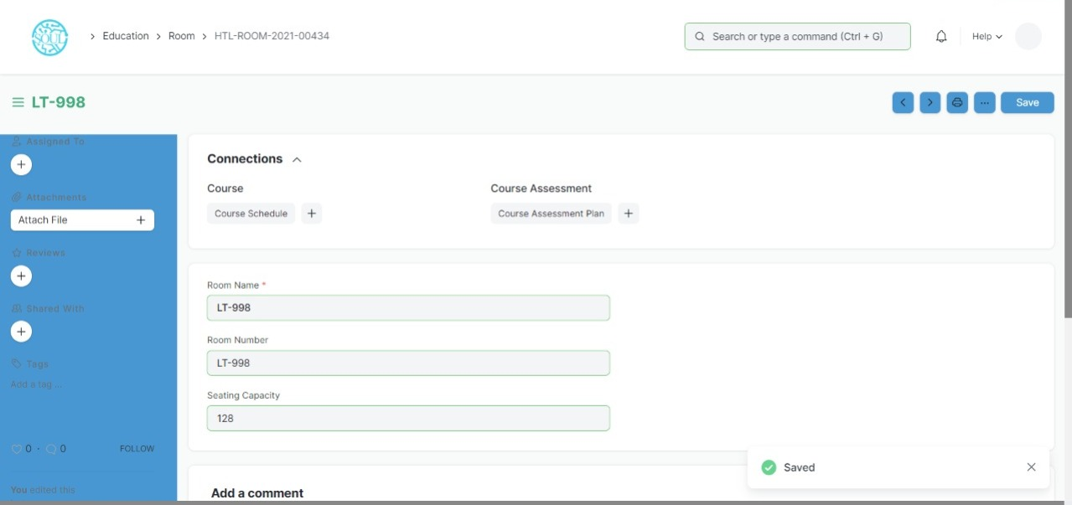Enter the Seating capacity for the room.

#### Other Actions

A Room can be further linked to a Course Schedule.

### Academic Year

An academic year is a period which the Educational Institutes, Schools and Universities use to measure a quantity of study.

The Academic year form have the Start and End date for the Academic year. Within an Academic Year, you can have multiple Academic Terms. An academic Year can be further liked to a Student Group, which can be created from an Academic Year.

If the Academic Year has been specified in the Education Settings, then it will become the default Academic Term in all the forms and will be editable if required.

To go to Academic Year, go to:

Home > Admission > Masters > Academic Year

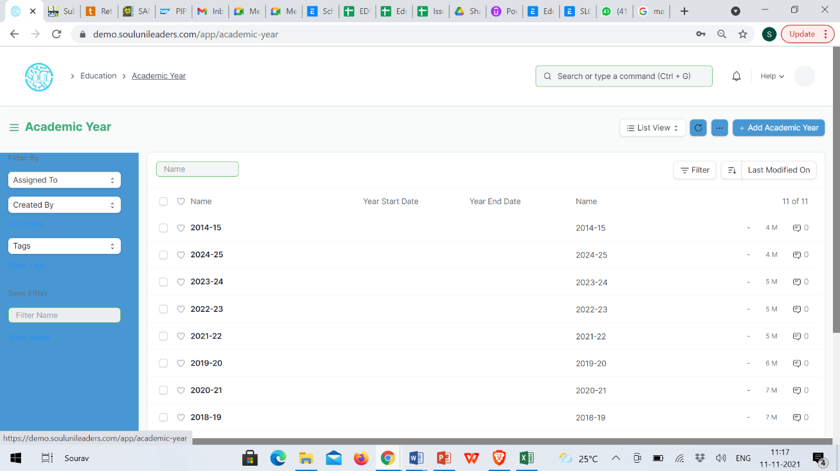The following are the various forms where Academic Year is a relevant field:

1. Student Log
2. Student Group
3. Student Applicant
4. Student Admission
5. Program Enrollment
6. Assessment Plan
7. Assessment Result
8. Assessment Criteria
9. Fees
10. Fee Schedule
11. Fee Structure
12. Fee Category
13. Course Schedule

### Academic Term

An Academic Term would become a part of the Academic Year, during which the Institute will assess its students on the curriculum defined for that term. It could be a Quarter, Trimester or a Semester.

To access Academic term, go to:

Home > Admission > Masters > Academic Term

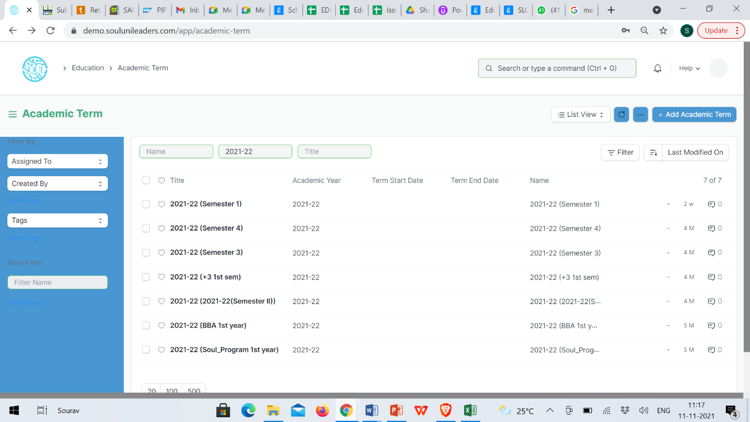

The Academic term form in EduLead enables you to create academic terms within in an Academic Year. Based on the term schedule enter the start and end date for the schedule and generate the Academic Term.

If the Academic Term has been specified in the Education Settings, then it will become the default Academic Term in all the forms and will be editable if required.

The following are the various forms where Academic Term is a relevant field:

1. Student Log
2. Student Group
3. Student Applicant
4. Student Admission
5. Program Enrollment
6. Assessment Plan
7. Assessment Result
8. Assessment Criteria
9. Fees
10. Fee Schedule
11. Fee Structure
12. Fee Category
13. 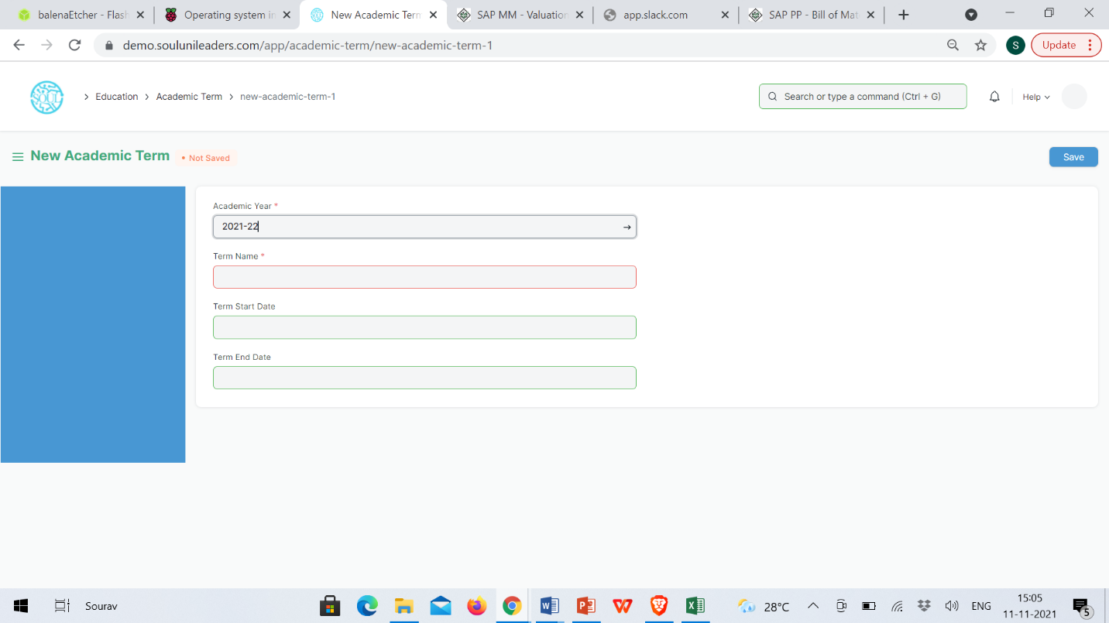Course Schedule

## Student & Instructor

Student

The Student document will hold all the data of any Student in your Academy like their Personal Information, Photo, Date of Birth, Address, etc.

This form will also contain any additional details like the Student's Guardian and Sibling details.

The student is enrolled in a Program when the application is approved. Once the enrollment is done the Student Applicant status is update to Admitted.

To access Student, go to:

Home> Admission > Student & Instructor > Student

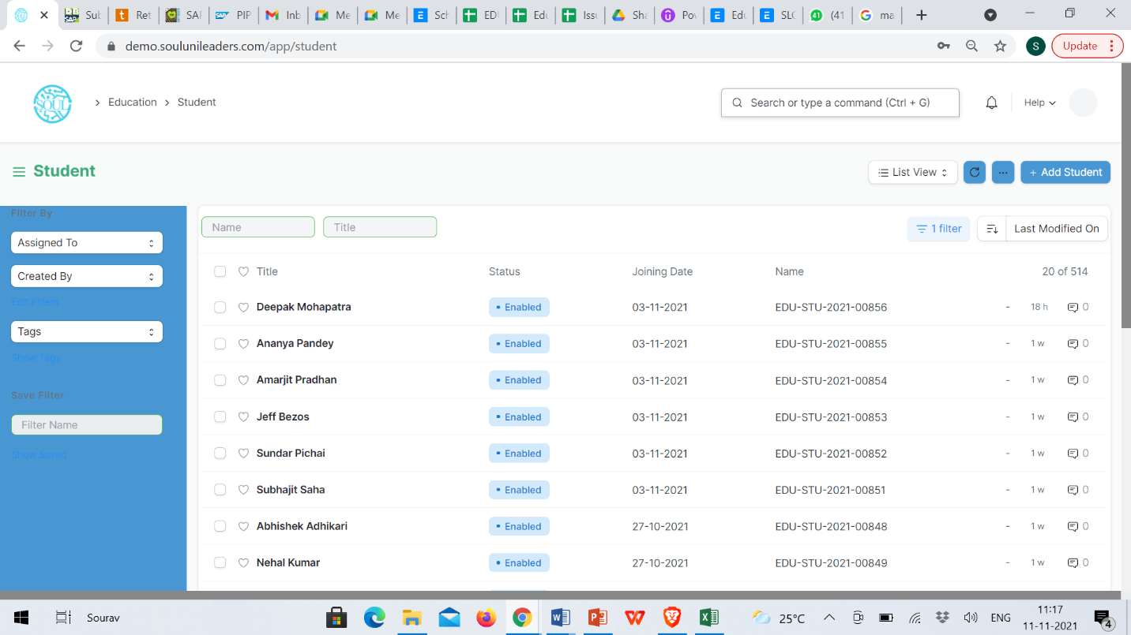

#### Prerequisites

Before creating a student, it is advised to create the following first:

* User (If Applicable)

#### How to create a New Student?

1. Go to the student list and click on New.
2. Enter the First Name, Middle Name and Last Name of the student.
3. Enter other details like Student Email Address, User ID (If Applicable) and Joining Date.
4. Save.

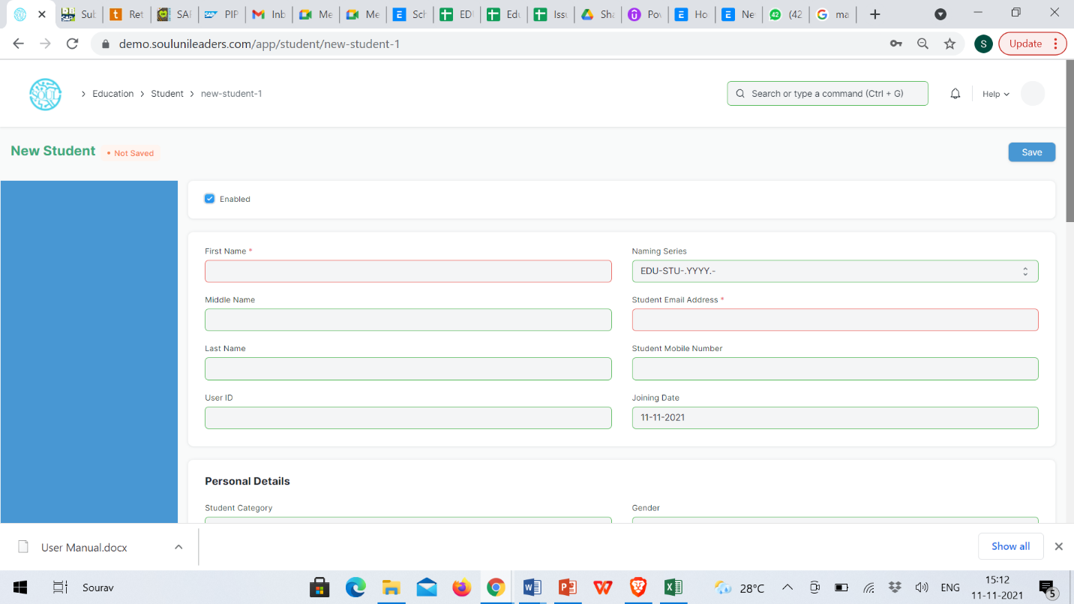

#### Features

Apart from the aforementioned details, some additional details of the student that can be captured are as follows:

1. **Personal Details**

Personal details of the Student like their Date of Birth, Gender, Blood Group, and Nationality can be added here.

1. **Home Address**

The address of the student, along with the City, State, and Pin code can be captured here. Two address lines can be captured for each student.

1. **Guardian Details**

The details of the student's guardian and their relationship with the student can be captured here. You can create a Guardian from here itself, or create a guardian first and then create the Student.

1. **Sibling Details**

This section will have all the details of the Student's Siblings. You can select if the sibling is studying in the Same Institute or no. If the Sibling is also a student of your institute, you will be required to enter their Student ID, if not, you can enter the name of the Institution they are associated with. Their academic details like Program and personal details like Gender and Date of Birth can also be captured.

1. **Exit Details**

The Student's exit details can be captured here, like their Date of Leaving, and Leaving Certificate Number as captured in your institute's records can be captured. Further, you can also enter the Reason for Leaving in here.

***Note: On top of the student form, there is an 'Enabled' checkbox using which the student by default would always be enabled. Once you have recorded the Student's Exit Details, you must uncheck this box to disable the student.

1. **After Saving**

Once you save the Student Form, the student gets created in the system and you will be able to link this document to other documents related to Admission, Assessment, Attendance, Student Activity, Student LMS Activity, and Fees. Further, you will also be able to see a dashboard that will indicate their activities throughout the year.

#### Other actions

Once a student is created in the system, you can also view the Accounting Ledger, which will show a report of all the payments made by the student.

#### Related Topics

1. Guardian
2. Student Group
3. Student Attendance
4. Program
5. Course

Instructor

An instructor is a teacher, tutor, or a professor that will be responsible for teaching a particular topic or course to the students.

This document can be used to maintain the Instructor Log in the form of a list of topics/courses covered by the Instructor. This log will have the entire history of the courses taught by the Instructor.

To access the instructor list, go to:

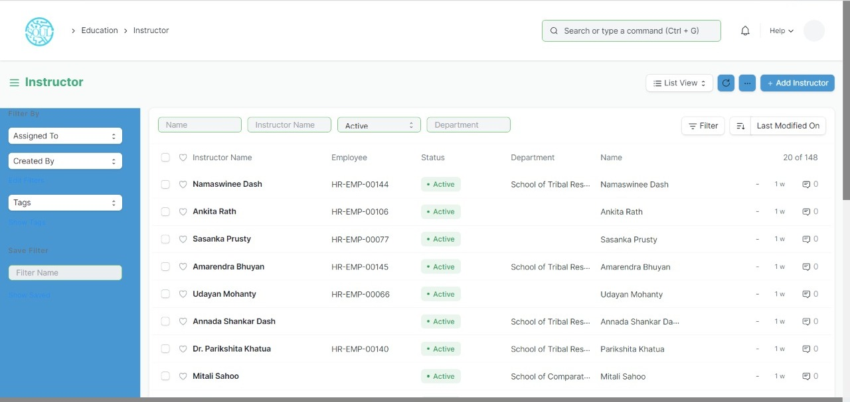Home > Education > Masters > Instructor

#### Prerequisites

Before creating an instructor, it is advisable to first create the following:

1. Employee
2. Department
3. Academic Year
4. Academic Term
5. Program
6. Course
7. Student Group

#### How to create an Instructor?

1. Click on New Instructor.
2. Select the Employee ID/Employee Name for the Instructor.
3. Select the Department for which you are creating an Instructor.
4. Save.

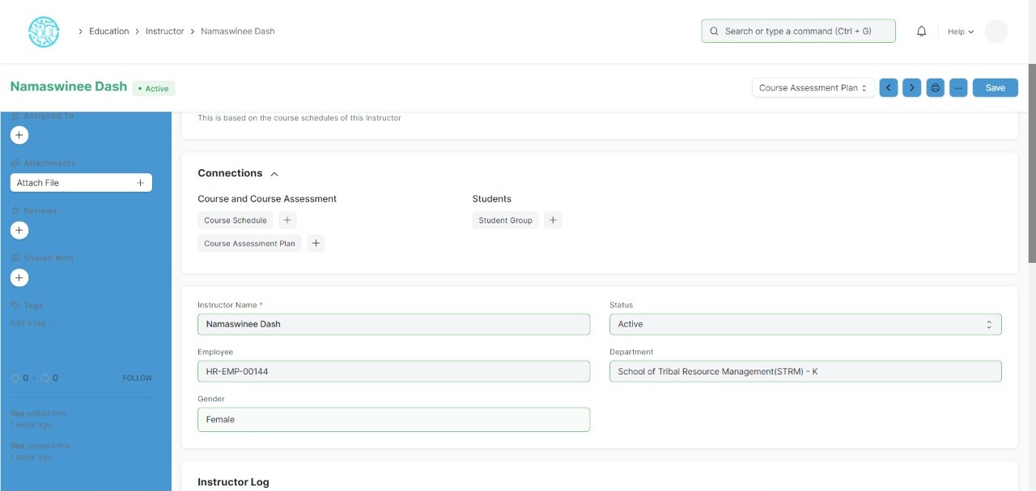

#### Features

* Instructor Log
* Academic Year: The Academic Year for which the Instructor is created.
* Academic Term: The Academic Term for which the Instructor is created.
* Department: The department to which the Instructor belongs to.
* Program: The Program for which the Instructor Log is being made.
* Course: The course for which the Instructor Log is being made.
* Student Group: The Student Group for which the user is making the Instructor Log.
* Other Details: Any other details regarding the Instructor Log can be recorded here.
* After Submitting

Once the Instructor and Instructor Log is saved, you can create the following from there:

1. Student Group
2. Course Schedule
3. Assessment Plan

***Note: While creating an Evaluation Plan from the Instructor, the user can select whether the Instructor has to be kept as a Moderator or as an Paper Setter for the Evaluation plan.

Guardian

Guardian allows you to record the details of the Guardians of a Student.

Every student can have multiple guardians like Father, Mother, Brother, or Sister.

To access Guardian, go to:

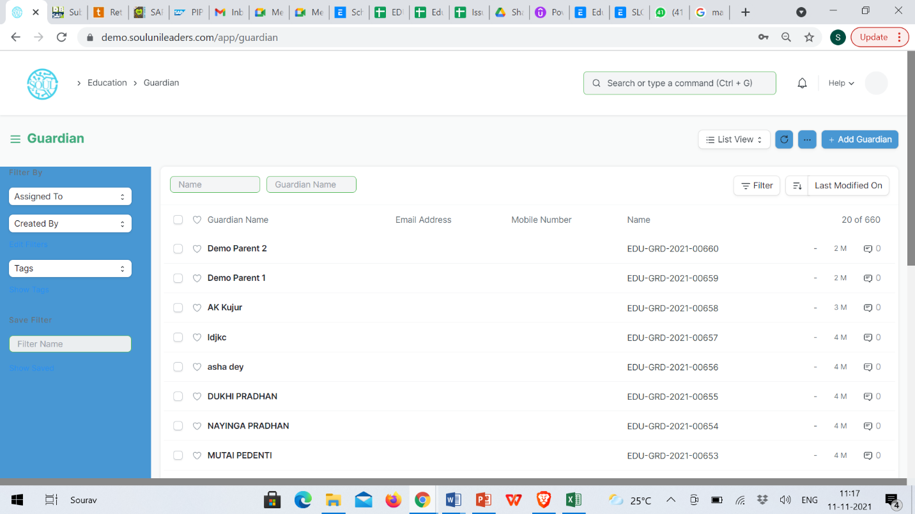Home > Education > Student > Guardian

#### Prerequisites

Before creating a Guardian, it is advised to create the following first:

* Student
* User

#### How to create a Guardian?

1. Click on New Guardian in the Guardian List.
2. Add the name of the Guardian and click on Save.

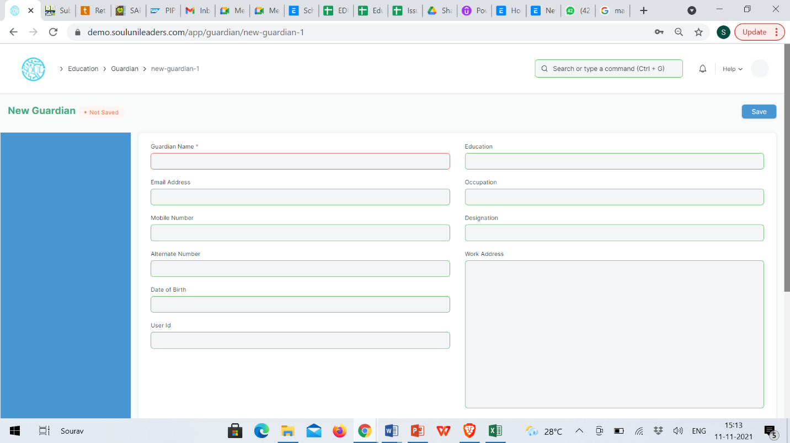

#### Additional Options while creating a Guardian

Apart from the mandatory details of the Guardian, you can also add the following details:

1. **Email Address:** Enter the email address of the Guardian. The email address can be linked to an email group for sending Newsletters or Announcements.
2. **Mobile Number:** The mobile number of the Guardian can be recorded here.
3. **Alternate Mobile Number:** You can add the Alternate Mobile Number of the Guardian over here for emergency purposes.
4. **Date of Birth:** The date of birth of the Guardian can be recorded here.
5. **User ID:** If the Guardian is a User of the system, their User Id can be mentioned here.
6. **Education:** The Academic and Educational details of the Guardian can be recorded here.
7. **Occupation:** The occupation of the Guardian can be captured here.
8. **Designation:** You can enter the designation of the Guardian here.
9. **Work Address:** The Work Address of the Guardian can be recorded here for emergency purposes.

#### Features

* 1. **Guardian of Students**

While creating a Student, if you have selected a Particular Guardian for them, the name of that Student will automatically be fetched here. Multiple students can have the same person as their guardian. In that case, multiple entries will be made in this section. However, on the front end, one will not be able to add more students to this section.

* 1. **Making the Guardian a User**

Once Guardian has been saved, you can find a button Invite as User on the top right corner of the form. This button would allow you to invite the guardian as a User of EduLead by sending them an invitation email on the recorded email ID.

#### Related Topics

Student

Student Category

Student Category allows you to classify the students based on various categories.

In Institutions, there may be fee concession for some categories such as Handicapped Students, Foreign Nationals, Reserved Categories by the government, etc.

When a Student is enrolled for a Program, you can select the select the Category for the Student.

To access Student category, go to:

Home > Education > Settings > Student Category

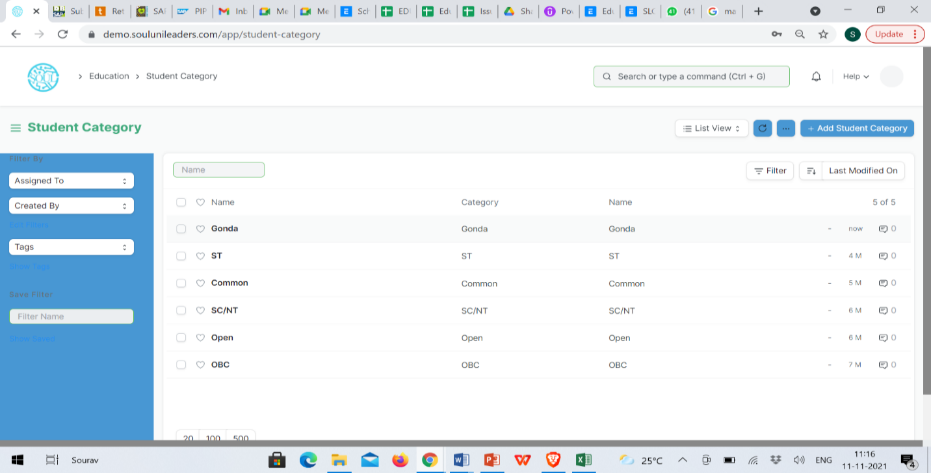

#### How to create a Student Category?

To create a new student category, click on New Student Category and add the name of the Student Category.

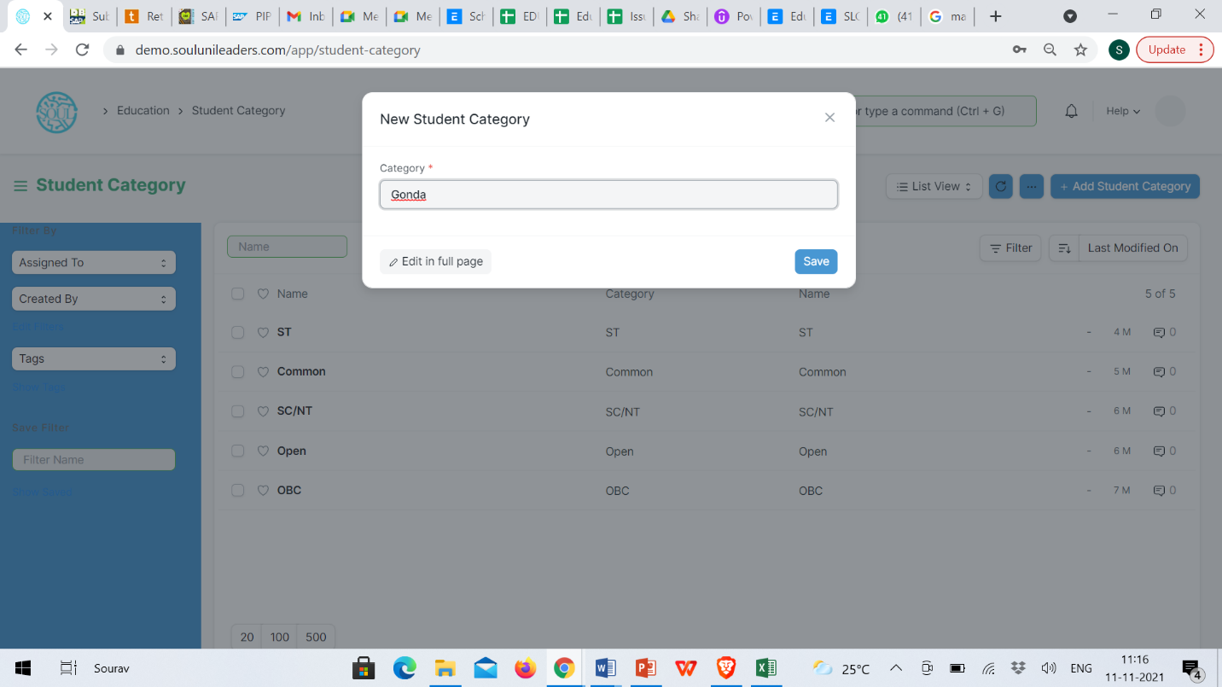You can select the Student Category while making the Fee Structure and accordingly the student from the selected groups can be filtered out while making the Fee Schedule.

## 

Student Log

The student Log will act as a Student Diary, wherein, all their logs and other notes can be recorded.

A student log can be used to record the student's performance in General, Academic, Medical or Achievement terms.

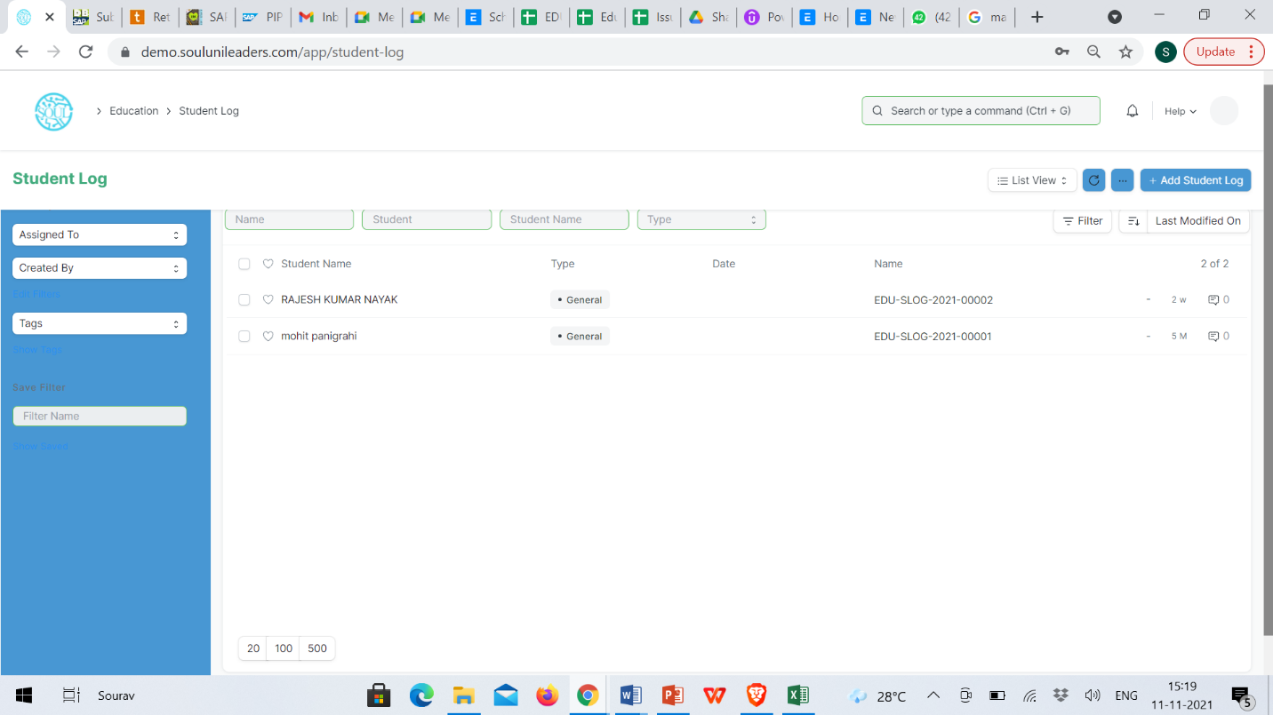To access Student Log, go to:

Home > Education > Student > Student Log

#### Prerequisites

* Student
* Academic Year
* Academic Term
* Program
* Student Batch

#### How to create a Student Log?

* 1. Go to Student Log List and click on New.
  2. Enter the Student ID. The moment you do this; the name of the student will automatically be fetched.
  3. Save.

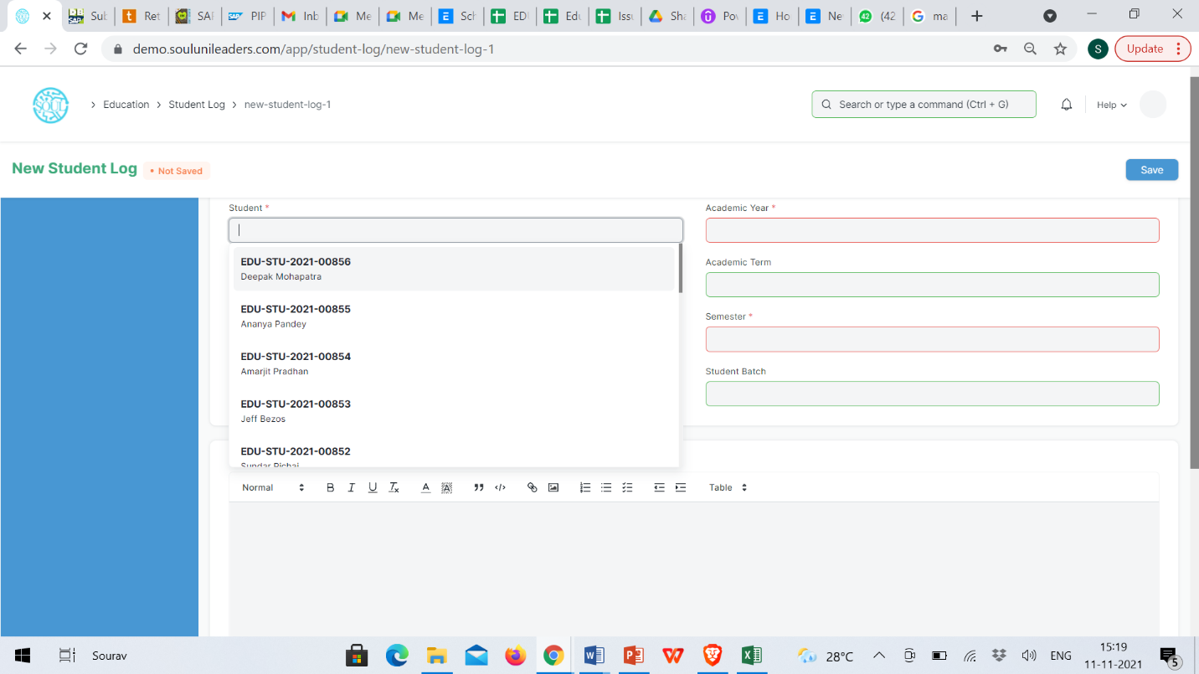

#### Additional Options while creating a Student Log

* Type: You can enter the type of the Log that is being created for the student. A student log can be a General, Academic, Medical or Achievement log.

Following are some examples wherein you can make a log for the student:

* + General: If the student was extremely well behaved during the entire day or if they were sleeping during the class.
  + Academic: If a student gets a full score in a surprise test, or if they get a very bad score.
  + Medical: If the student was found not having their lunch, or if they complained of some other medical issue.
  + Achievement: If the student scored a goal for the team in a football match.
* Date: You can select the date on which the log was entered.
* Academic Year: You can select the academic session for which this log is being made.
* Academic Term: You can select the term in which this log is being recorded.
* Program: Select the Program under which the student is enrolled.
* Student Batch: Select the batch of which this student is a part of.
* Log: This field will have your note of log for the student.

Student Batch

A Student batch is a collection of students from within Student Groups.

For example, a group of students studying the same Program together will be called a Student Batch.

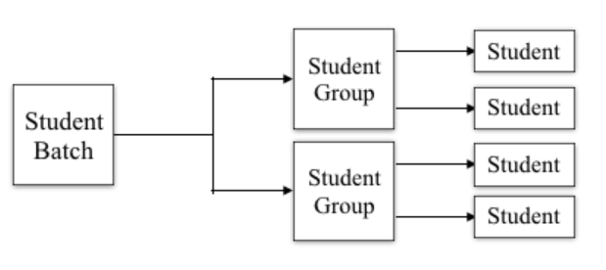To access the Student Batch, go to:

Home > Education > Settings > Student Batch Name

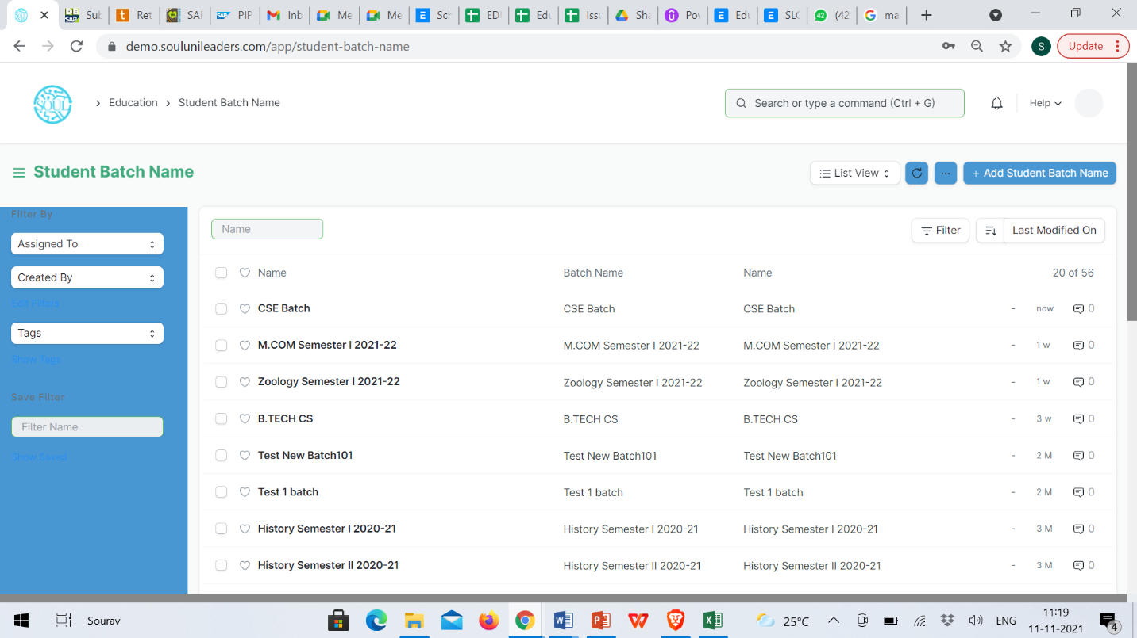When a student is enrolled for a Program, the batch can be selected for the student, and they shall be a part of that batch.

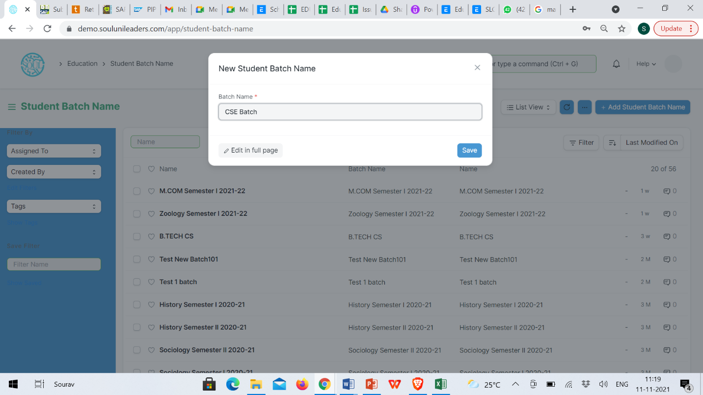You can also get a Student Batch-Wise Attendance report to view the number of students present from the Batch.

## Admission Masters

Document Template

Document Template is a list of all the different templates required for getting admission in a particular class. Document Template is primarily used while creating a student admission for a class.

To access Document Template, go to:

Home > Admission > Admission Masters > Document Template

#### Prerequisite:

* Academic Year
* Student Category
* Documents

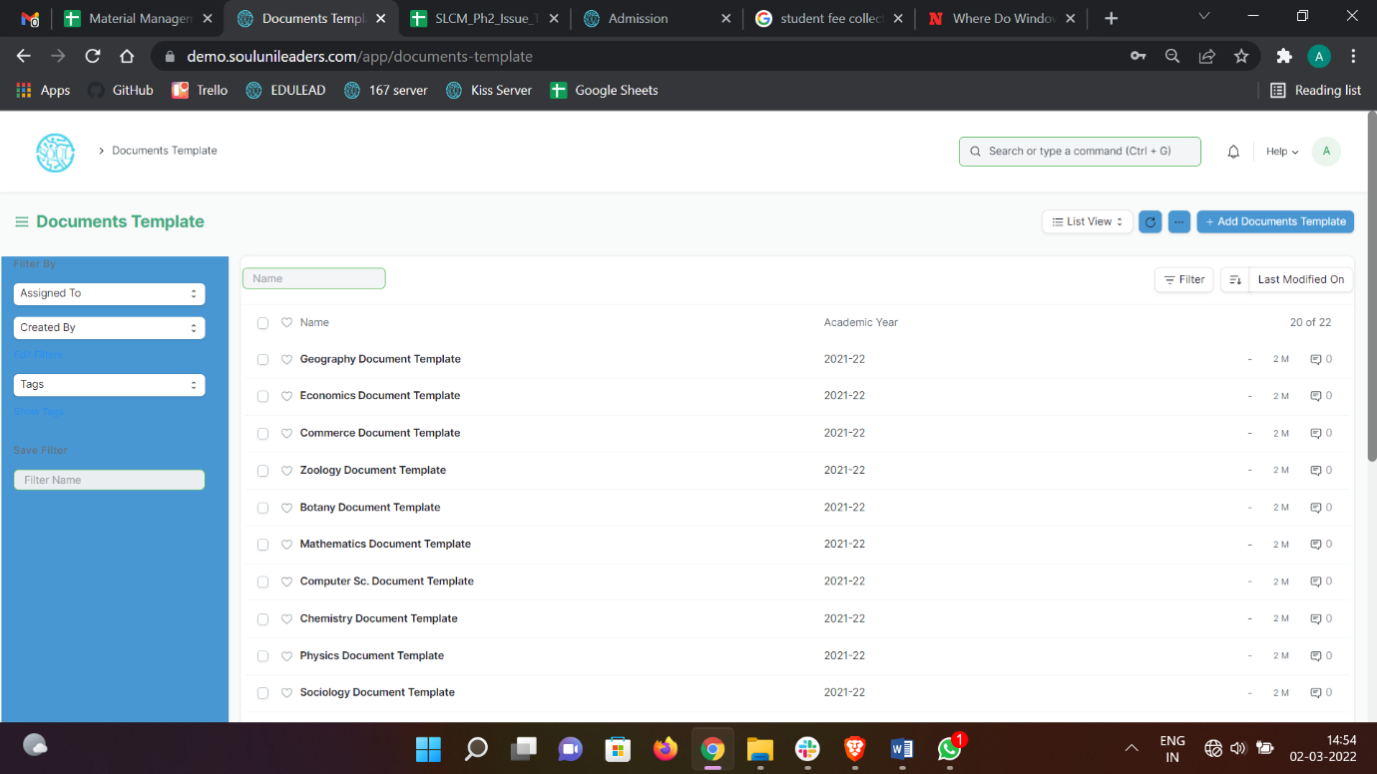

#### How to create a Document Template?

#### Click on Add Documents Template.

#### Add Template Name, Academic Year.

#### Check Is Active button.

#### Add Description.

#### Select Student Category from the list of dropdown that appears.

#### In the Document Required Table add all the different Documents.

#### Save.

Academic Events

An Academic Events are individual events which is used for creating Academic Calendar while preparing Schedule for a Class.

To access Academic Events, go to:

Home > Admission > Admission Masters > Academic Events

#### C:\Users\KIIT\Pictures\Screenshots\Screenshot (62).pngHow to create an Academic Event?

1. Click on Add Academic Events.
2. Add Event Name.
3. Save.

Academic Calendar Template

Academic Calendar Template is a list of all different events that will be happening in an Academic year for a particular class.

For Every Class a separate Academic Calendar Template will be created and later be linked while declaring admission for that class.

To access Academic Calendar Template, go to:

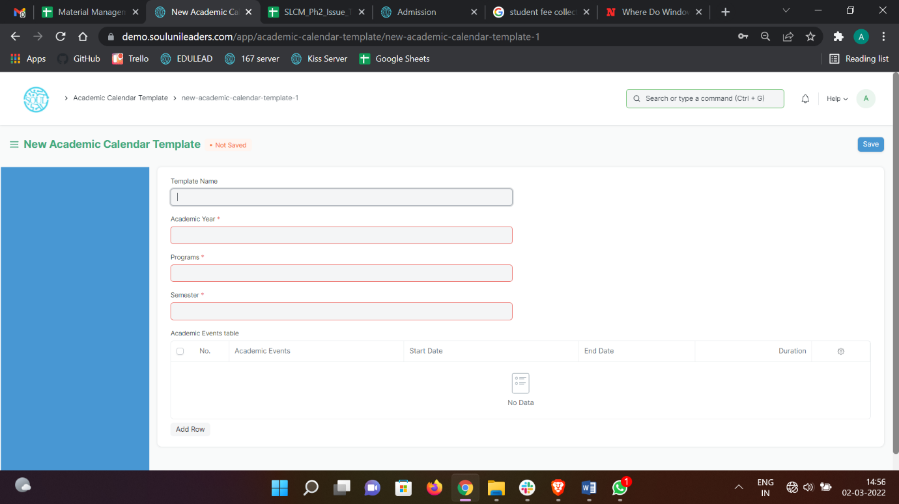Home > Admission > Admission Masters > Academic Calendar Template

#### Prerequisite:

1. Academic Year
2. Class
3. Academic Events

#### How to create an Academic Calendar Template?

* 1. Click on Add Academic Calendar Template.
  2. Add Template Name.
  3. Select Academic Year and Class from the List that appears on clicking on those fields.
  4. Select Academic Events and add Starting date, End date for the events.
  5. Save.

Academic Calendar

Academic calendar is a schedule of all of the events that occur in an academic year. These events may include examination dates, spring break or reading week and the last day of the semester. It can also be useful for prospective students, alumni, and parents as well. Each educational institution creates its own academic calendar with their own defined dates.

To access Academic Calendar, go to:

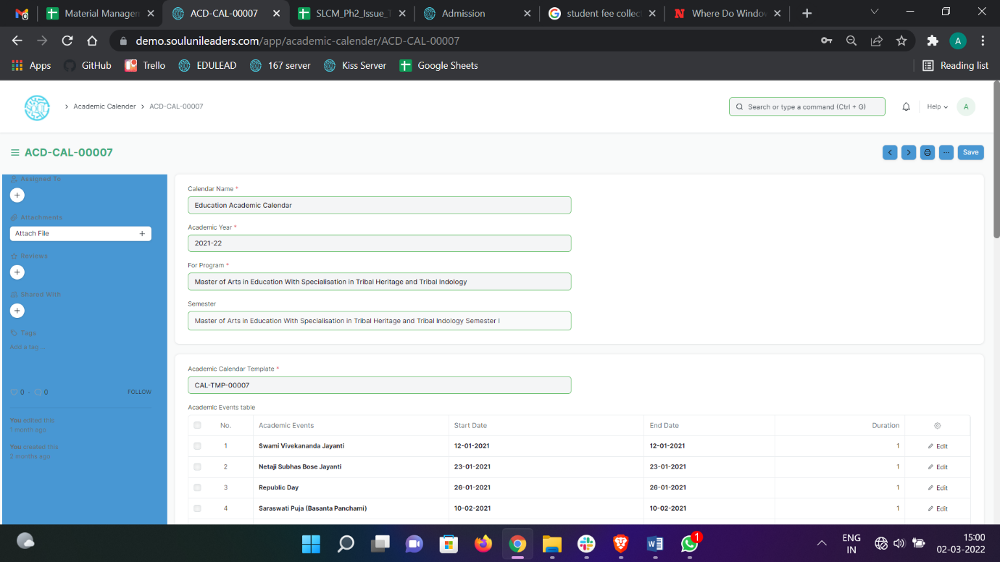Home > Admission > Admission Masters > Academic Calendar

#### Prerequisite:

* + - 1. Academic Calendar Template
      2. Academic Year
      3. Program

#### How to create an Academic Calendar?

Click on Add Academic Calendar Template.

Select and enter Calendar Name.

Select and enter Academic Year.

Select and enter “For Program”.

Select and enter “Academic Calendar Template”.

The details mentioned in Academic Calendar Template is auto-fetched.

Save and Submit.

Eligibility Parameter

An Eligibility Parameter is a label based on which Students eligibility is checked while defining Student admission.

To access Eligibility Parameter, go to:

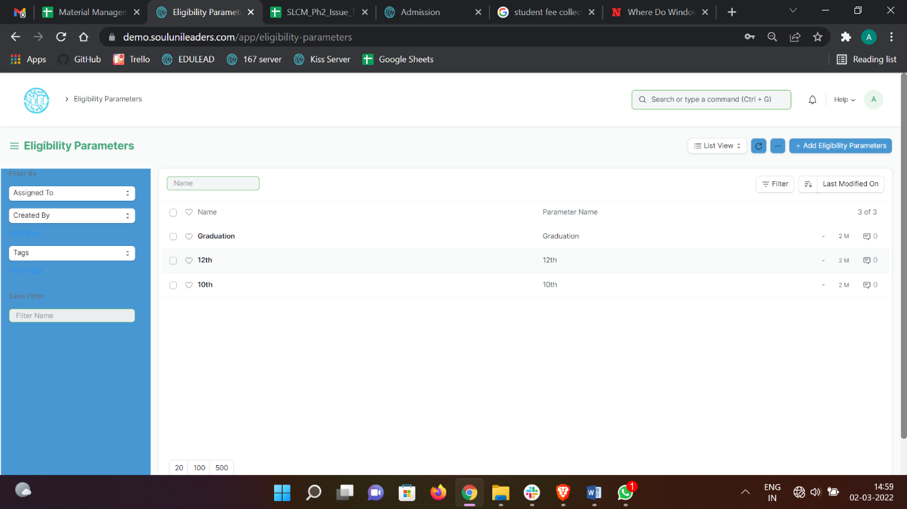Home > Admission > Admission Masters > Eligibility Parameter

#### How to create an Eligibility Parameter?

1. Click on Add Eligibility Parameter.
2. Add Parameter name.
3. Save.

## Counselling

Counselling Structure

During counseling it will suggest college according to your rank and branch which will show on display if you choose any college then your request will be locked and you have to pay some amount which will discount on admission time. In most of courses like medical or engineering, college counselling is engaged so a student can know about the various courses offered by different colleges where he or she can pursue his/her career confidently.

To access Counselling Structure, go to:

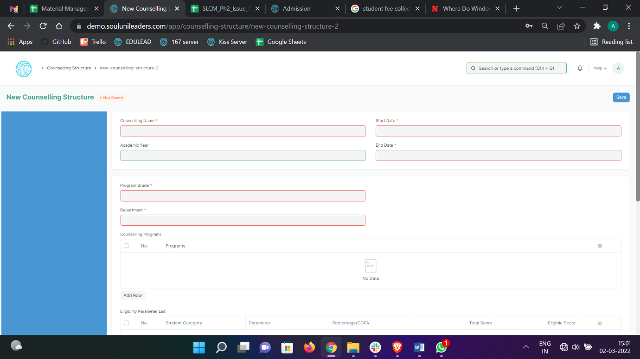Home > Admission > Counselling > Counselling Structure

#### How to create Counselling Structure?

* + - 1. Click on Add Counselling Structure.
      2. Select and enter Counselling Name.
      3. Select Start Date and End Date.
      4. Select and enter Academic Year(optional).
      5. Select and enter Program Grade.
      6. Select and enter Department.
      7. Select and enter Programs (from the above selected Department only) in the “Counselling Programs” table.
      8. Select and enter “Eligibility Parameters” table.
      9. Select and fill the “Fees” table (if any).
      10. Select and fill the “Required Documents” table.
      11. Save and Submit.

## Application & Enrolment

1. Student Admission

Student Admission is a document which can be configured to initiate an Admission Process for your institution by publishing it on the EduLead generated website.

To access student Admission, go to:

Home > Admission > Application & Enrollment > Student Admission

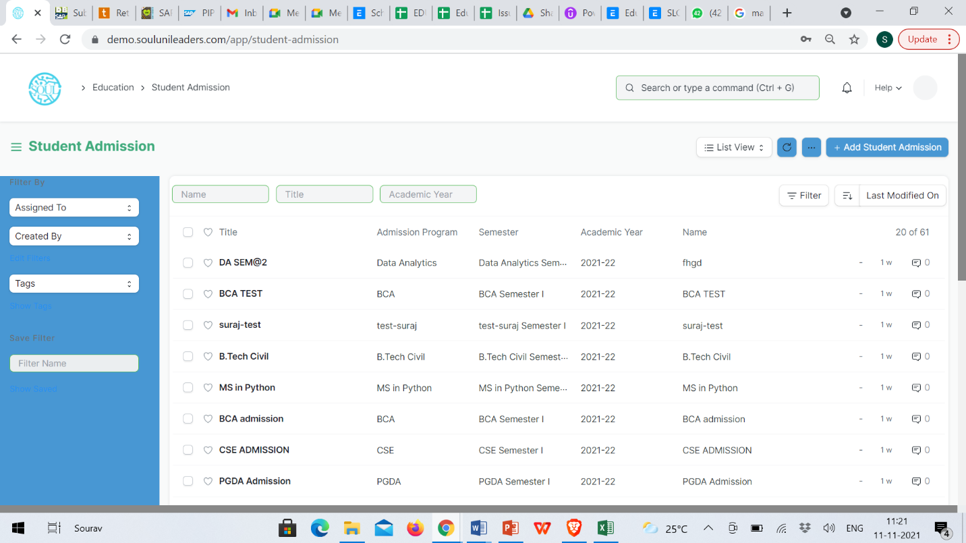

#### Prerequisites

Before creating a Student Admission, it is advisable that you first create the following:

1. Academic Year
2. Program

#### How to create a Student Admission?

1. Go to Student Admission list and click on New.
2. Select the Academic Year for the Student Admission.
3. Enter the Application Form Route. This is the navigation URL for the Online Admission portal.
4. Save.

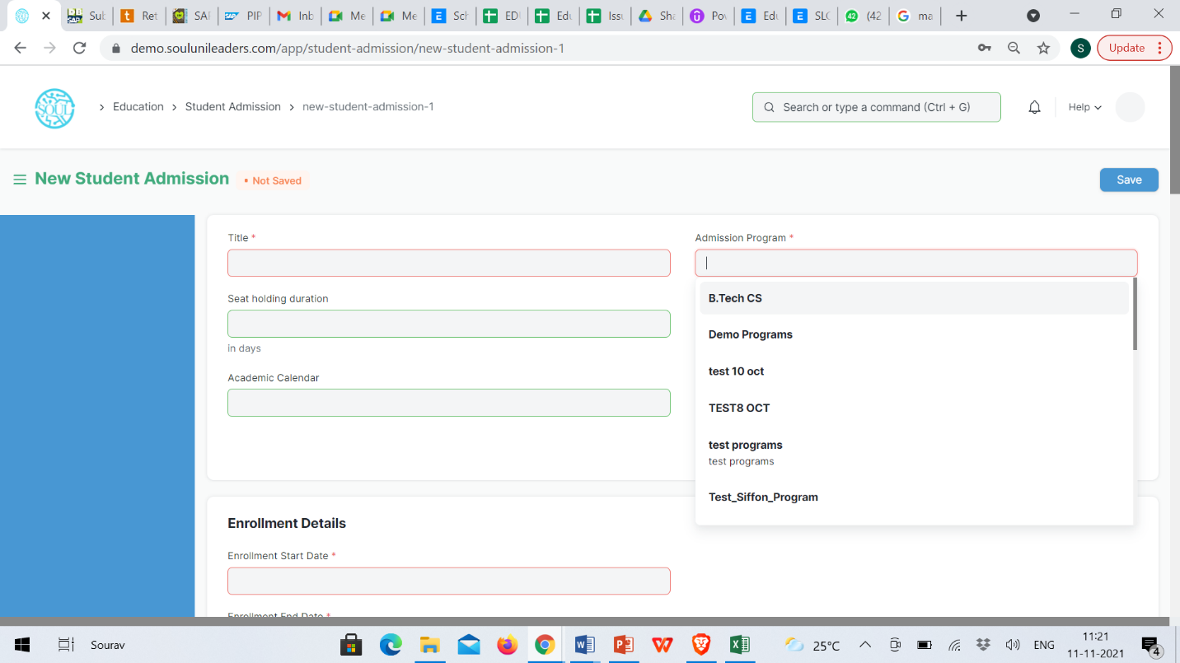

Once the Student Admission has been saved, you will be able to see a link on the left sidebar, saying See on Website. This link will allow you to see the Student Admission Portal on EduLead generated website.

#### Additional Details while creating a Student Admission

1. Title: Enter the title for the Student Admission Portal.
2. Route: Enter a desirable path which will become the URL extension for the admission portal.
3. Admission Start Date: Select the date for the start of online Admission Process.
4. Admission End Date: Select the last date for applying to online Admission Process.
5. Publish on Website: Check this box when the content of the portal is ready and the Admission Process can be kick started on the website.

#### Eligibility and Details

* Program: Here you can select which program are the admissions being called for.
* Minimum Age: Enter the probable birth-date of the youngest person that can seek admission in the program.
* Maximum Age: Enter the probable birth-date of the oldest person that can seek admission to the program.
* Application Fee: You can choose to declare the application fee for the selected program.
* Naming Series: Here you can define the Naming series based which the forms of the Admission Seekers will be named and ordered.

**Introduction: You can add a brief introductory information about the admission process so that it is better understood to the admission seekers. **

1. Student Applicant

A Student Applicant record gets created when a student applies to your institute for admission.

You can Approve or Reject a student applicant. By accepting a student applicant, you can add them to the student master.

To access student Applicant, go to:

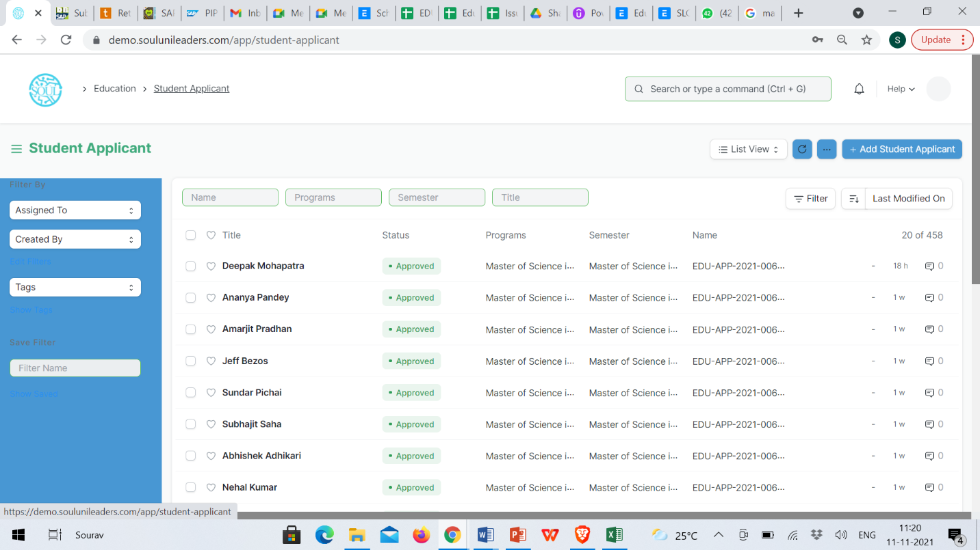Home > Education > Admission > Student Applicant

#### Prerequisites

Before creating a Student Applicant, it is advisable to first create the following:

1. Academic Term
2. Academic Year
3. Program

#### How to create a Student Applicant?

1. Go to the student Applicant and click on New.
2. Enter the First Name of the student Applicant.
3. Enter the Program for which the student has applied.
4. Enter the Student Email Address.
5. Save.

#### Features

**Online Application via a Web Form**

A Student Applicant gets automatically created when a student applies online. This can be made possible through the Student Applicant Web Form which is created by default in the system. Search for "Web Form List" in the awesome bar to access the list of all the web forms in the system.

Once the student applies, the status of the application by default is "Applied". You can either "Approve" or "Reject" the form.

Once the application is approved, you can "Enroll" the student to a program. When you click the Enroll button, the system shall create a student against that applicant and redirect you to the Program Enrollment form.

***Note: Once a student is created against the student applicant, the system will set the application status to 'Admitted' and will not allow you to change the application status unless the student record is deleted.

1. Program Enrollment

Program Enrollment is the record of enrollment of a student in a given program and chosen courses for a particular Academic Term.

To ensure that students are associated with a particular program in the system, their Program Enrollment must be created. The mandatory course in that program is automatically filled in the Enrolled Courses table while the elective or optional courses can be selected manually.

If the student has applied online for the admission in a particular Program and the application is approved, then the Program Enrollment can be created from within the Student Applicant record via clicking on the Enroll button. Checkout Student Applicant for more information on this.

To access Program Enrollment, go to:

Home > Admission > Application & Enrollment > Program Enrollment

#### C:\Users\KIIT\Pictures\Screenshots\Screenshot (175).pngPrerequisites

Before creating a Program Enrollment, it is advisable that you create the following first:

1. Student
2. Program
3. Student Category
4. Student Batch
5. Academic Year
6. Academic Term
7. Course
8. Fee Structure

#### How to create a Program Enrollment?

1. Go to Program Enrollment List and click on new.
2. Select the Student whom you are getting enrolled in the program.
3. Select the Program under which you are getting the student enrolled.
4. Enter the Academic Year for which the student is getting enrolled.
5. The Enrollment Date for the form would by default be set on the current date, the same, however, can be changed if needed.
6. Save and Submit.

#### C:\Users\KIIT\Pictures\Screenshots\Screenshot (67).pngAdditional Options while creating a Program Enrollment

1. Student Category: Select the category if the student belongs to a particular student category.
2. Academic Term: Select the Academic Term.
3. Student Batch: Select the batch if the student belongs to a particular student batch.
4. Student House: Select the House if the student belongs to a particular student house.
5. Boarding Student: Check this if the Student is residing at the Institute hostel. In this case, the fee structure would accordingly be updated.

#### Features

* **Enrolled Courses**

Select and add the courses which the student has opted to study during the course of the program.

1. Course Enrolment

Course Enrollment is the record of enrollment of a student in a given program and chosen courses for a particular Academic Term.

To ensure that students are associated with a particular program in the system, their Course Enrollment must be created/auto-generated. The mandatory course in that program is automatically filled in the Enrolled Courses table while the elective or optional courses can be selected manually.

If the student has applied online for the admission in a particular Program and the application is approved, then the Course Enrollment is auto-created from within the Program Enrollment record.

To access Course Enrollment, go to:

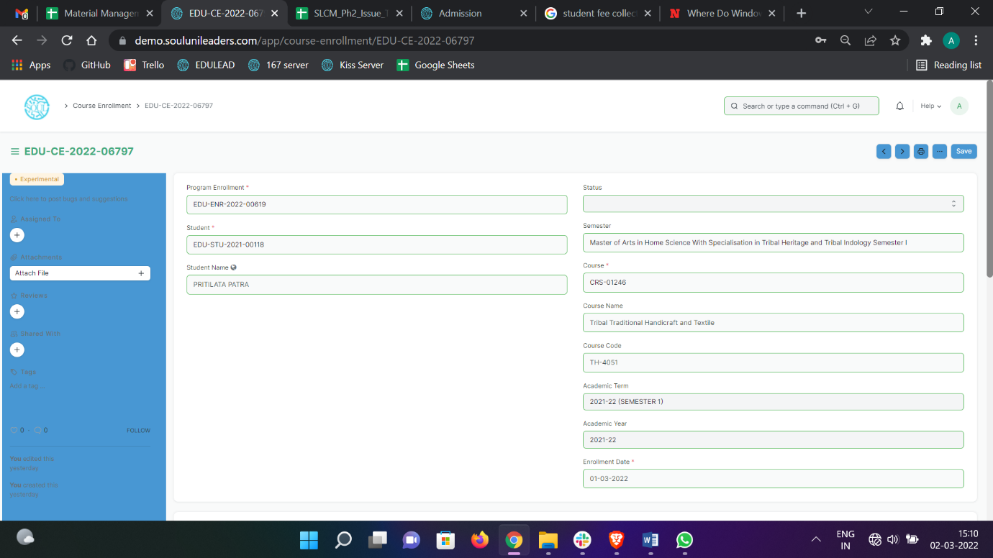Home > Admission > Application & Enrollment > Course Enrollment

## Branch Change & Exchange Application

1. Branch Change Declaration

There are generally three methods of changing stream after taking admission in an engineering college. Firstly, when you are filling your entrance form for admission in college. There will be obvious an upward movement in the whole scenario so that you can upward your branch from the current allotted branch.

Second method of branch changing is college level internal sliding which seldom present in all colleges.

Third method is by your first year grades. You can change your branch before entering in second year if you have good grades in your first year exam.

To access Branch Change Declaration, go to:

Home > Admission > Branch Change & Exchange Application > Branch Change Declaration

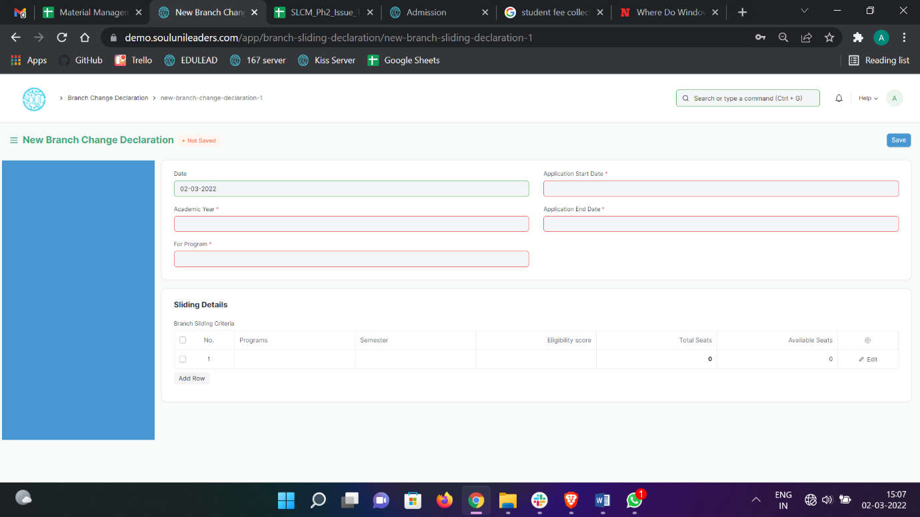

#### How to create Branch Change Declaration?

1. Go to Branch Change Declaration, click on Add Branch Change Declaration.
2. Select and enter “For Program”.
3. Select and enter Application Start Date and Application End Date.
4. Select and enter in Sliding Details table.
5. Select and enter Program Name in Branch Sliding Criteria for which Branch Change is declared.
6. Select and enter the Semester.
7. Select and enter Eligibility score.
8. Click on Edit option.
9. Select Update Seats option in the new pop-up screen.
10. Select Add or Deduct Balance in “Type”.
11. Select and enter no of seats.
12. Save.
13. Submit.
14. Branch Change Application

Branch change gives a student another chance to pursue the branch of his/her choice and passion. It is a second chance for those who have got into the institute of their choice but failed to get into their preferred branch, like a blessing which comes with a cost but the prize is more than worth it.

Changing your branch allows you to re-define your stay in the institute. A decision to be considered seriously and work hard for, to achieve what they want.

At the end of the first year, CGPA is the most important criterion for the eligibility of the branch change. Moreover, since the number of students entering into a certain department is limited the competition is tough which requires a greater amount of efforts from the students who are desperate for a branch change.

To access Branch Change Application, go to:

Home > Admission > Branch Change & Exchange Application > Branch Change Application

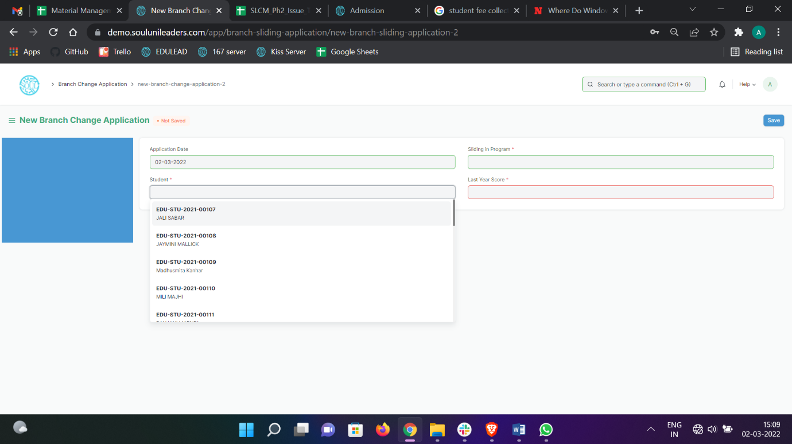

#### How to create a Branch Change Application?

* + - 1. Go to Branch Change Application, click on Add Branch Change Application.
      2. Select and enter Student Name.
      3. Select “Sliding in” and choose the option from the dropdown menu.
      4. Select and enter Last Year Score (In Percentage).
      5. Save and Submit.

1. Exchange Program Declaration

A student exchange program is a program in which students from an educational institution travel to a foreign country as a student of their institution’s partner institution in the host country and vice versa. It needs to be understood that the student who travels abroad on this program may or may not be required to study at the foreign university or school.

For students to register for an exchange program, an exchange program declaration is created first so that they can apply for this exchange programme.

To go to Exchange Program Declaration, go to:

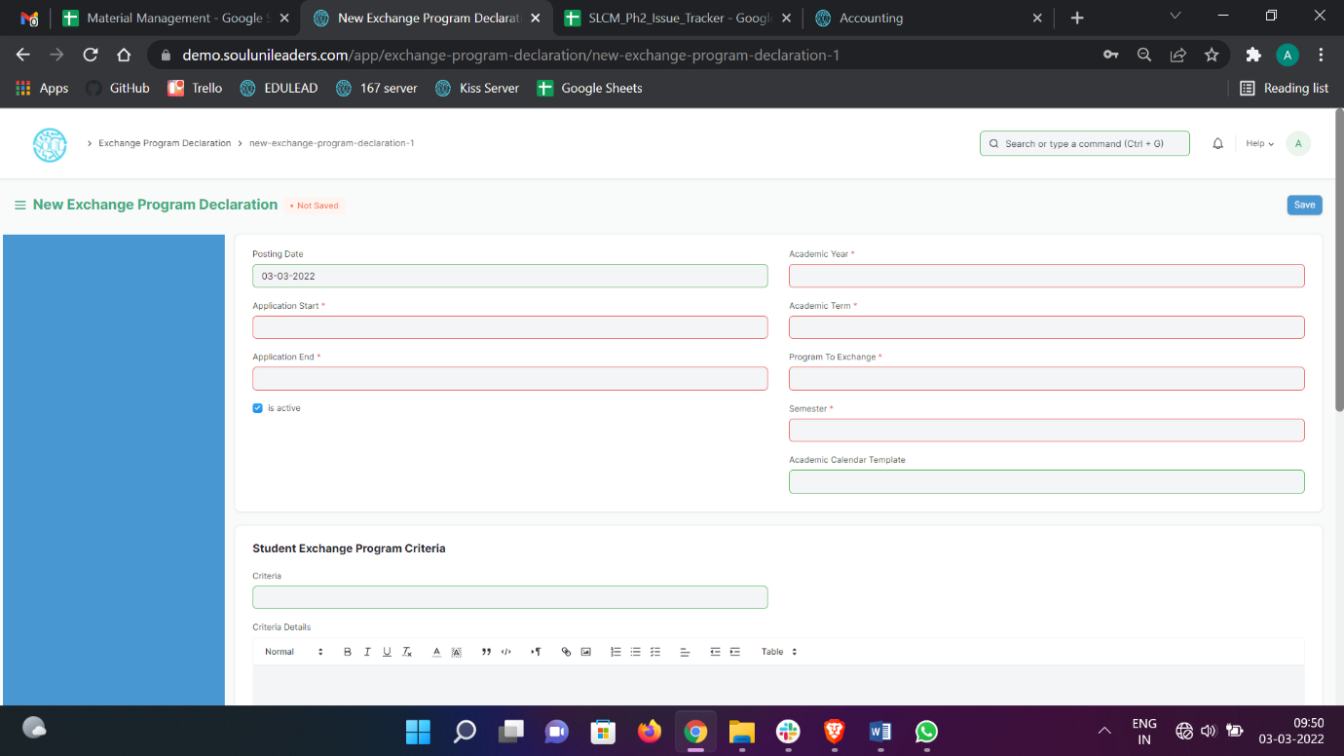Home > Admission > Branch Change & Exchange Application > Exchange Program Declaration

#### How to create Exchange Program Declaration?

1. Go to exchange program declaration, click on Add Exchange Program Declaration
2. Select and enter Application Start Date and Application End Date.
3. Select and enter “Program to Exchange”.
4. Select and enter the corresponding semester.
5. Select and enter Academic Template.
6. Select and enter Criteria for Student Exchange Program.
7. Select and enter any information in the Criteria Details if required.
8. Select and enter list of Required Documents/Document Template.
9. Select if Fees applicable.
10. Save and Submit.
11. Student Exchange Applicant

A student exchange program application is submitted by a student who wants to go for exchange programmes in a university study abroad at one of their institution's partner institutions. A student exchange program may involve international travel, but does not necessarily require the student to study outside their home country.

To go to Student Exchange Application, go to:

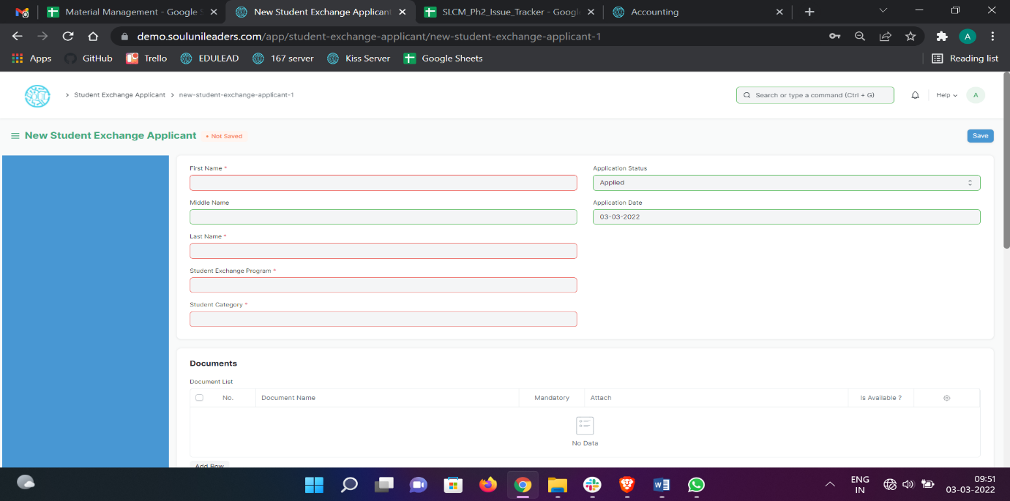Home > Admission > Branch Change & Exchange Application > Student Exchange Applicant

#### How to create Student Exchange Applicant?

#### Go to Student Exchange Applicant, click on Add Student Exchange Applicant.

#### Select and enter First Name, Middle Name and Last Name.

1. Select and enter Student Exchange Program.
2. Select and enter Student Category.
3. Select and attach the required documents as mentioned in the Document List.
4. Select and enter the Personal Details in the next table accordingly:
   1. Date of Birth
   2. Gender
   3. Student Email Address
   4. Student Mobile Number
   5. Blood Group
   6. Nationality
5. Select and enter Home Address.
6. Select and enter Education Qualification Details.
7. Select and enter Guardian Details.
8. Save.
9. Submit.

## Fees

1. Fee Structure

A Fee Structure is a template that can be used while making Fees records or generating them via the Fee Schedule.

The Fee structure can be fetched while creating the [Fees](https://docs.erpnext.com/docs/v13/user/manual/en/education/fees) for each student.

To access Fee Structure, go to:

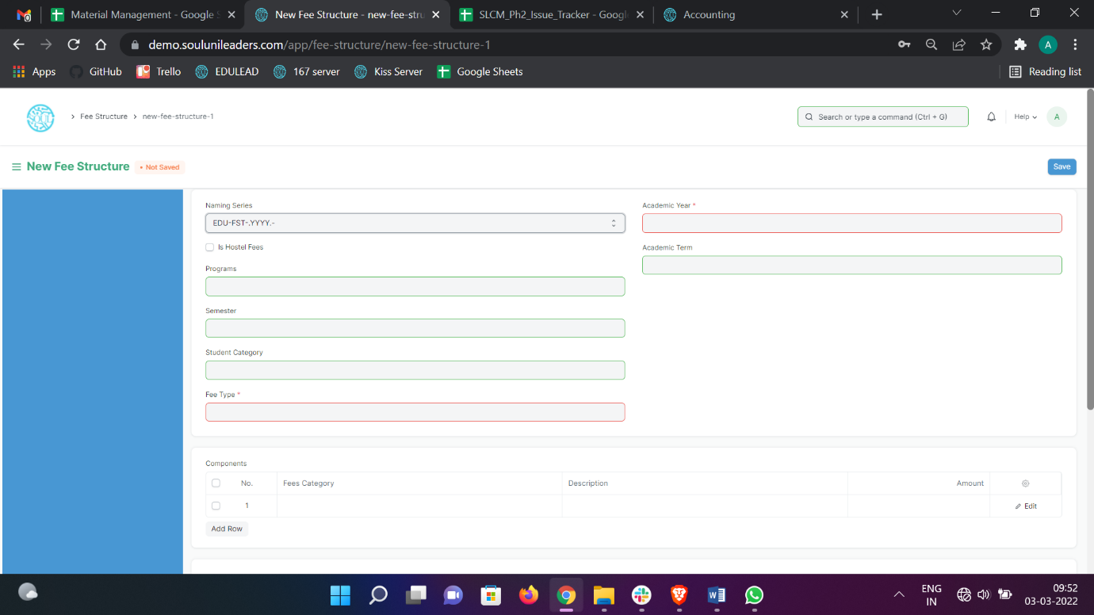Home > Admission > Fees > Fee Structure

#### Prerequisites

Before creating a Fee Structure, it is advisable that you create the following first:

1. Class
2. Academic Year
3. Fee Type
4. Fee Category

#### How to create a Fee Structure?

1. Go to Fee Structure List and click on new.
2. Select Class, Academic Year, Student Category, Fee Type.
3. Add Fee Category and Amount in the Components table.
4. Save.
5. Fee Schedule

Fee Schedule would help you in defining a time-line for the Fee payment of the students, based on the Student Group.

To access Fee Schedule, go to:

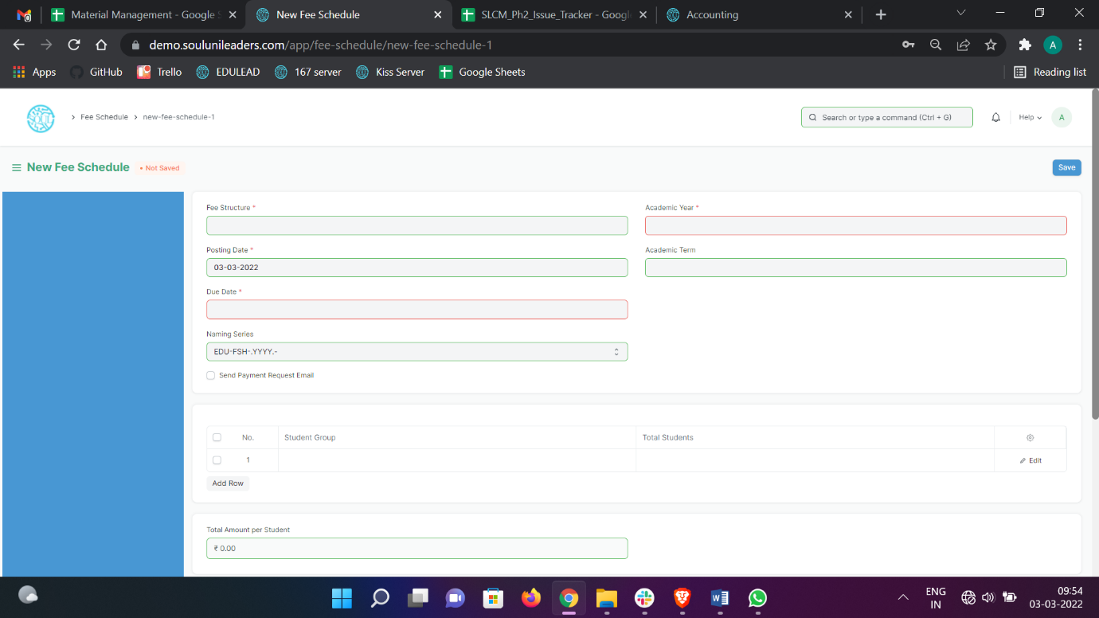Home > Admission > Fees > Fee Schedule

#### Prerequisites

Before creating a Fee Schedule, it is advisable that you create the following first:

1. Fee Structure
2. Student Group

#### How to create a Fee Schedule?

1. Go to Fee Schedule List and click on new.
2. Select Fee Structure.
3. Add Due date.
4. Select Student Group
5. Save.
6. Fee Category

Fee Category would form all the components for calculation of Fees or creation of Fee Structure.

For example, Tuition Fees and Hostel fees would make the different categories of fees.

To access Fee Schedule, go to:

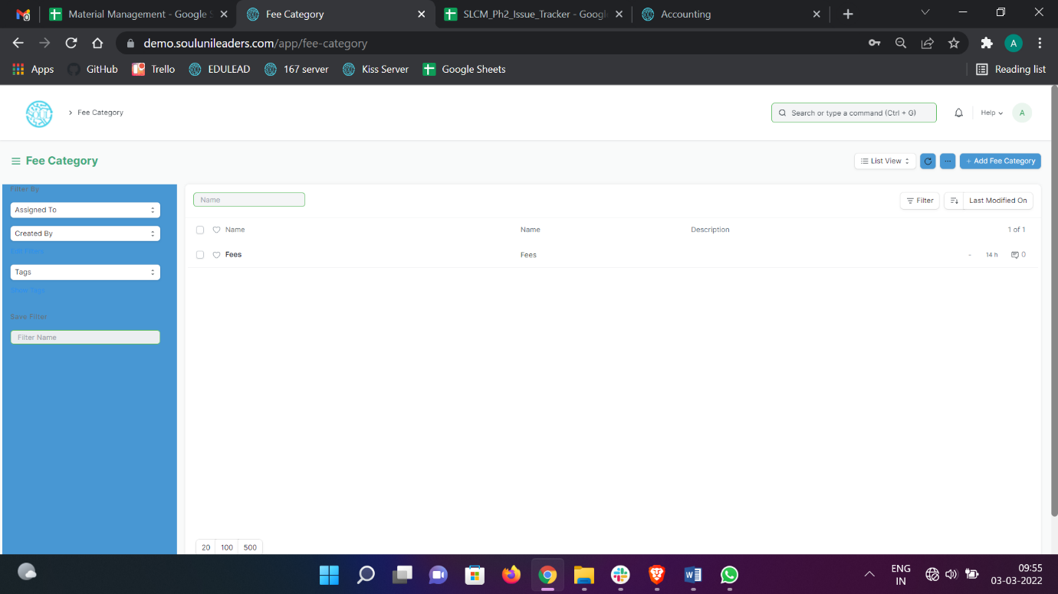Home > Admission > Fees > Fee Category

#### How to create a Fee Category?

1. Go to Fee Category List and click on new.
2. Enter Fee Category Name.
3. Save
4. Fees

By Creating Fees, we can maintain the Fee Records of the students.

At the time of submission of Fees by each student, a new Fees Record will be created wherein all the details of the student, Class they are enrolled in, Accounting information, etc. would be maintained.

To access Fee Schedule, go to:

Home > Admission > Fees > Fees

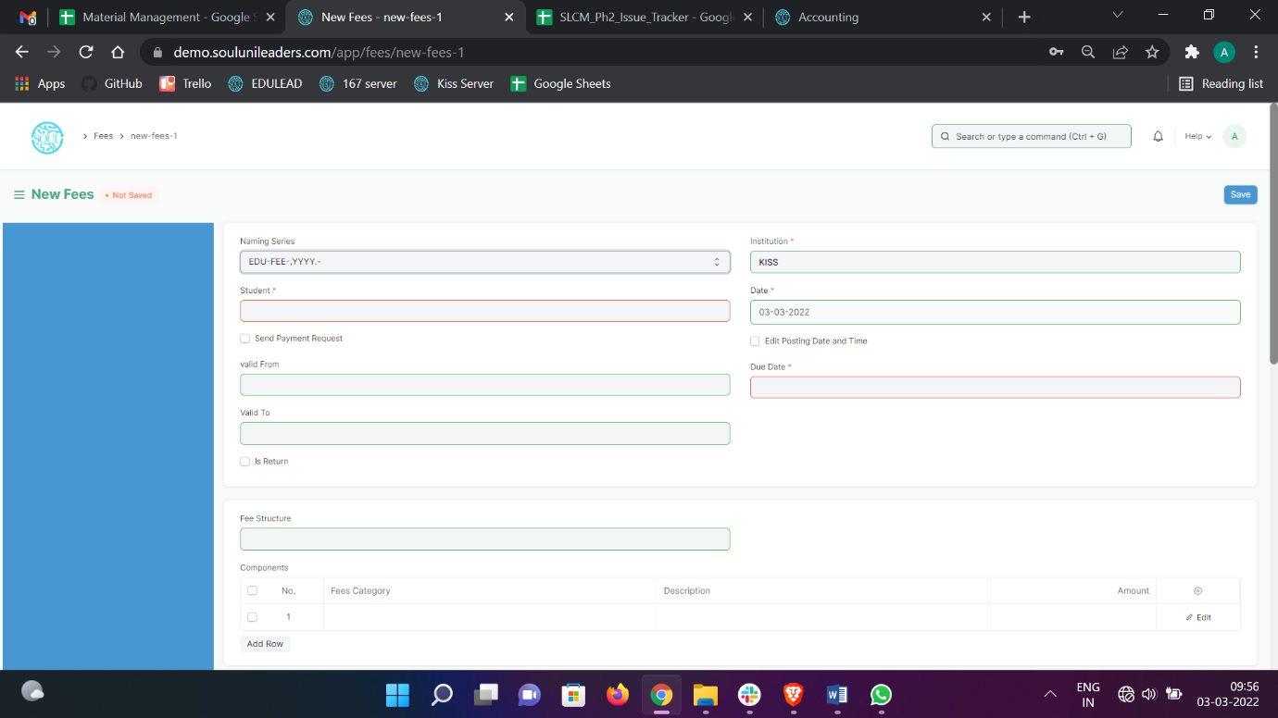

#### Prerequisites

Before creating a Fee Schedule, it is advisable that you create the following first:

1. Student
2. Fee Category
3. Fee Structure

#### How to create a Fees?

* + - 1. Go to Fee Category List and click on new.
      2. Select Student, Due Date, Valid from, Valid to.
      3. Select Fee Structure
      4. Add Receivable Account.
      5. Save.

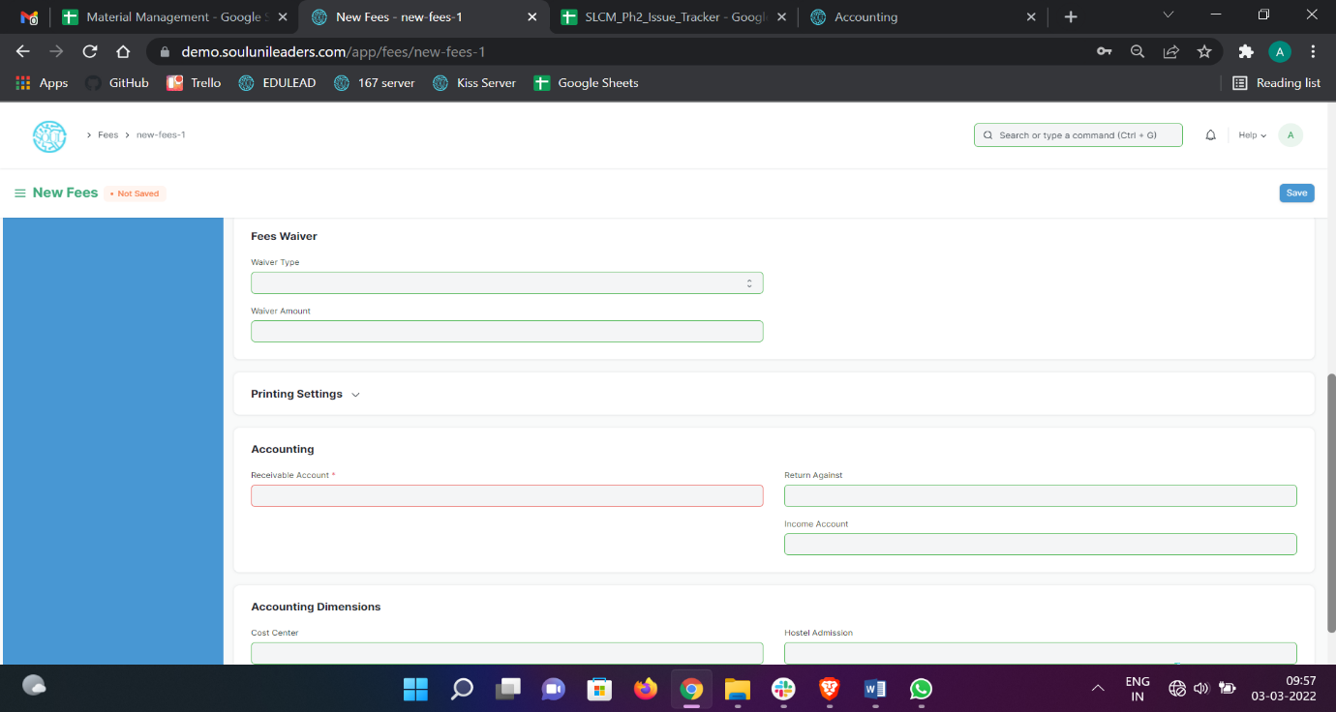

## Tools

1. Student Reregistration Tool

Students Reregistration tool is a tool for Reregistering the students once they have completed the examination and there is a need to promote the entire group of students to the next class.

To access Fee Schedule, go to:

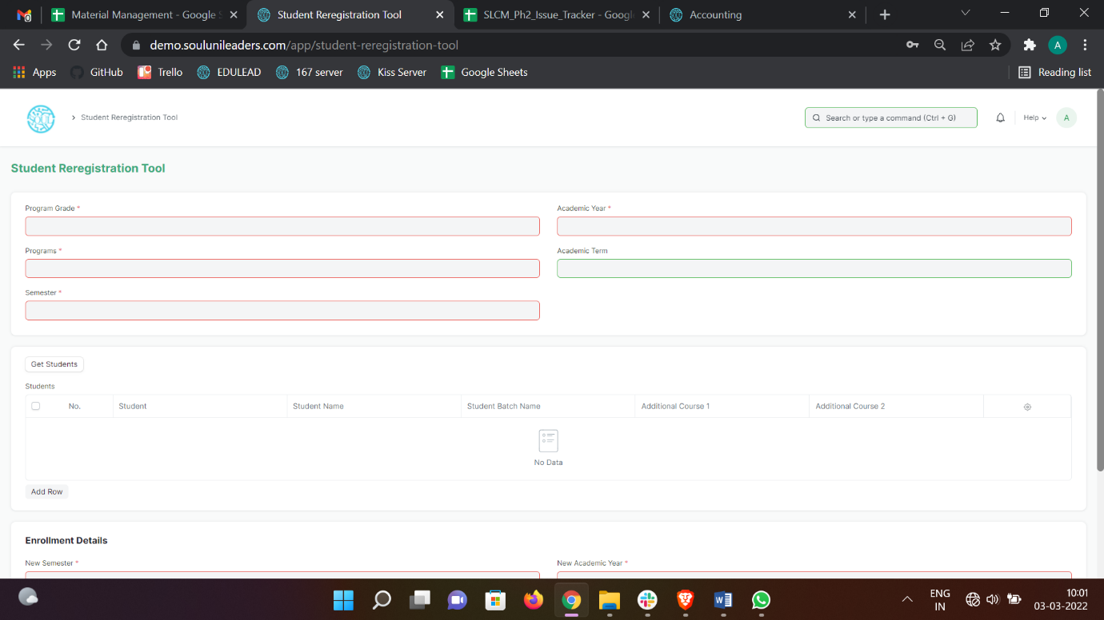Home > Admission > Tools > Student Reregistration Tool

#### Prerequisites

Before using the Student Reregistration tool, it is advisable that you create the following first:

1. Class
2. Section
3. Class Teacher
4. Class Coordinator
5. Academic Year

#### How to use Student Reregistration Tool?

1. Open Student Reregistration Tool.
2. Select Program Grade, Programs, Semester, Academic Year, Academic Term.
3. Click on the Get Student button and all the students for that program will be fetched in the table.
4. Select Additional Course if required.
5. Select and enter New Semester, New Student Batch, New Academic Year, New Academic Term.
6. The mandatory courses for the next semester will be auto fetched.
7. Click on “Enroll Students” button.

## Reports

1. Program Fees Report

Program Fees Report means the illustrative report of all amounts charged to the Applicant by the College in exchange for the Services the College provides which includes the Annual Fee and the Additional Fees.

To access Program Fees Report, go to:

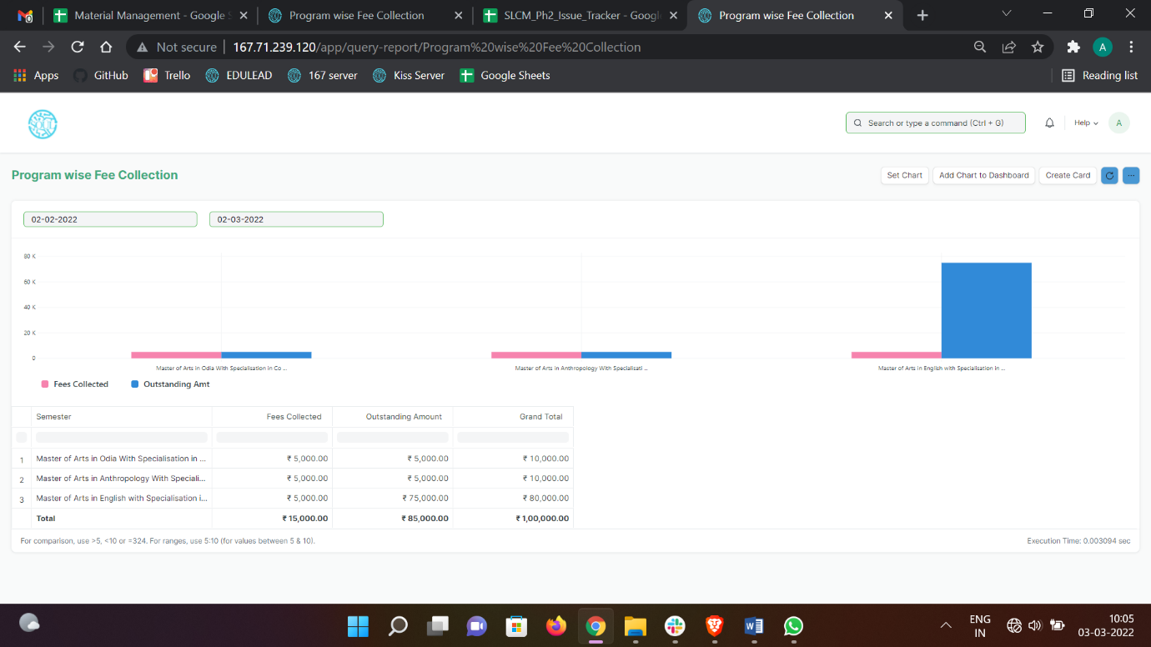Home > Admission > Report > Program Fees Report

#### How to generate Program Fees Report?

* + - 1. Click on Program Fees Report.
      2. Select the time duration during which the report is to be generated.
      3. Filter the report for individual semesters if required.
      4. Filter according to outstanding amount as well as fees collected.

1. Student Fee Collection Report

The main objective of the Student Fee Collection Report is to compute and display the fees of a student studying in a university. It is used to analyze the total amount collected from the Student as well any outstanding amount remaining.

To access Student Fee Collection Report, go to:

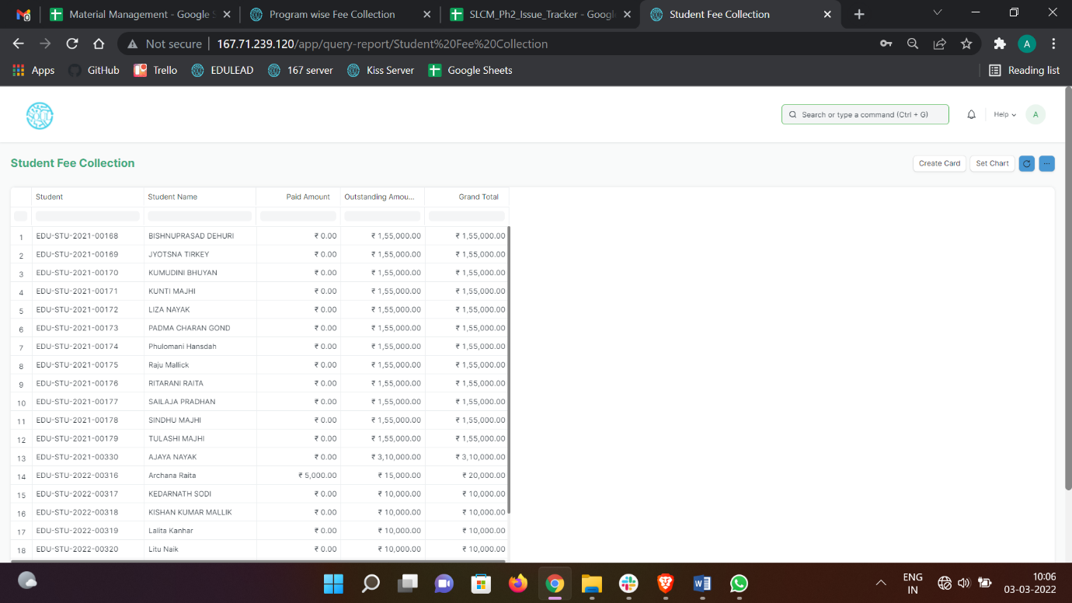Home > Admission > Report > Student Fee Collection Report

#### How to generate Student Fee Collection Report?

Click on Student Fee Collection Report.

Filter according to Student Name.

The Total Amount Paid, Outstanding Amount and Grand Total is all displayed accordingly.